WRDV301, Database Systems

PORTFOLIO
Nsovo Maswanganyi, 224788213

Table of Contents
1. Rubric 1
2. Class Submissions 2
Quiz 2
Normalization 4
Murder Mystery 6
Optimization 8
3. Assignments 9
Assignment 1 Draft 9
Assignment 1 Final 12
Assignment 2 Draft 15
Assignment 2 Final 17
Assignment 3 Draft 19
Assignment 3 Final 28
Assignment 4 Draft 29
Assignment 4 Final 32
Assignment 5 Draft 34
Assignment 5 Final 36
4. Reflection 38
The most valuable concept 38
Module aspects done well 39
Module aspects that need improvement 39
Life lesson 40

1. Rubric
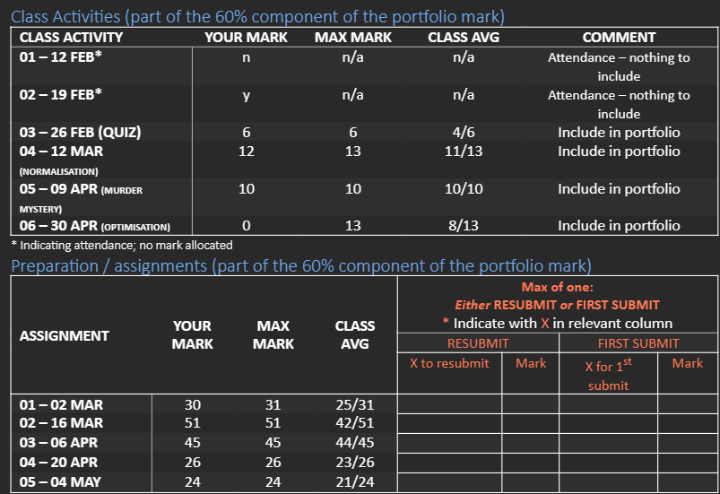
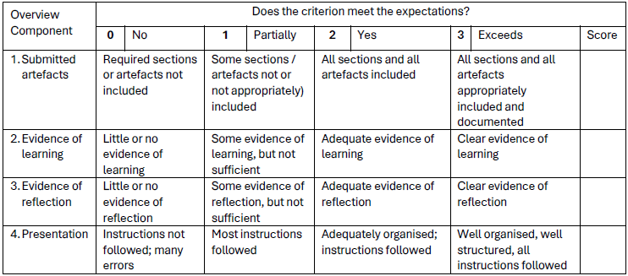

2. Class Submissions

Quiz

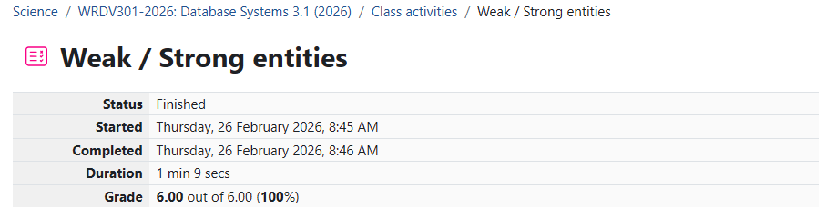
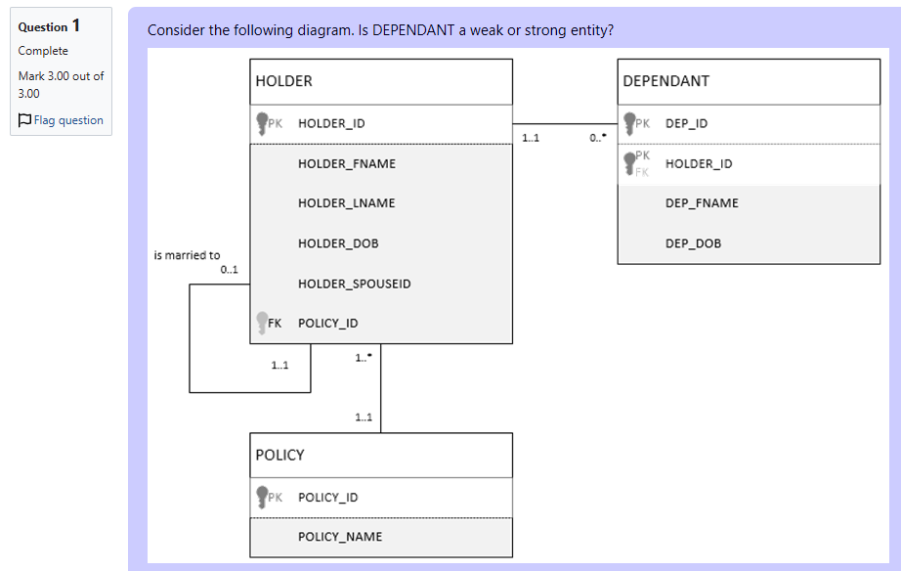
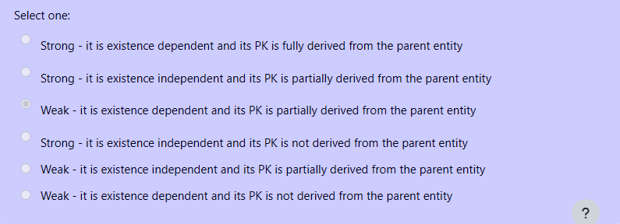
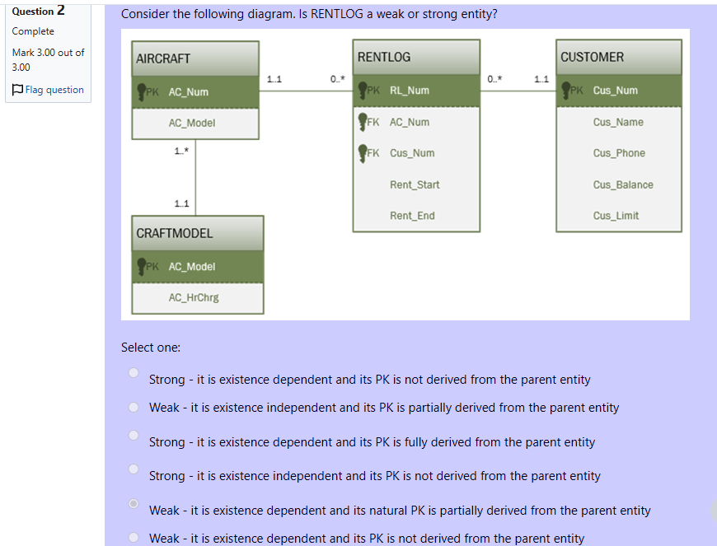

Normalization

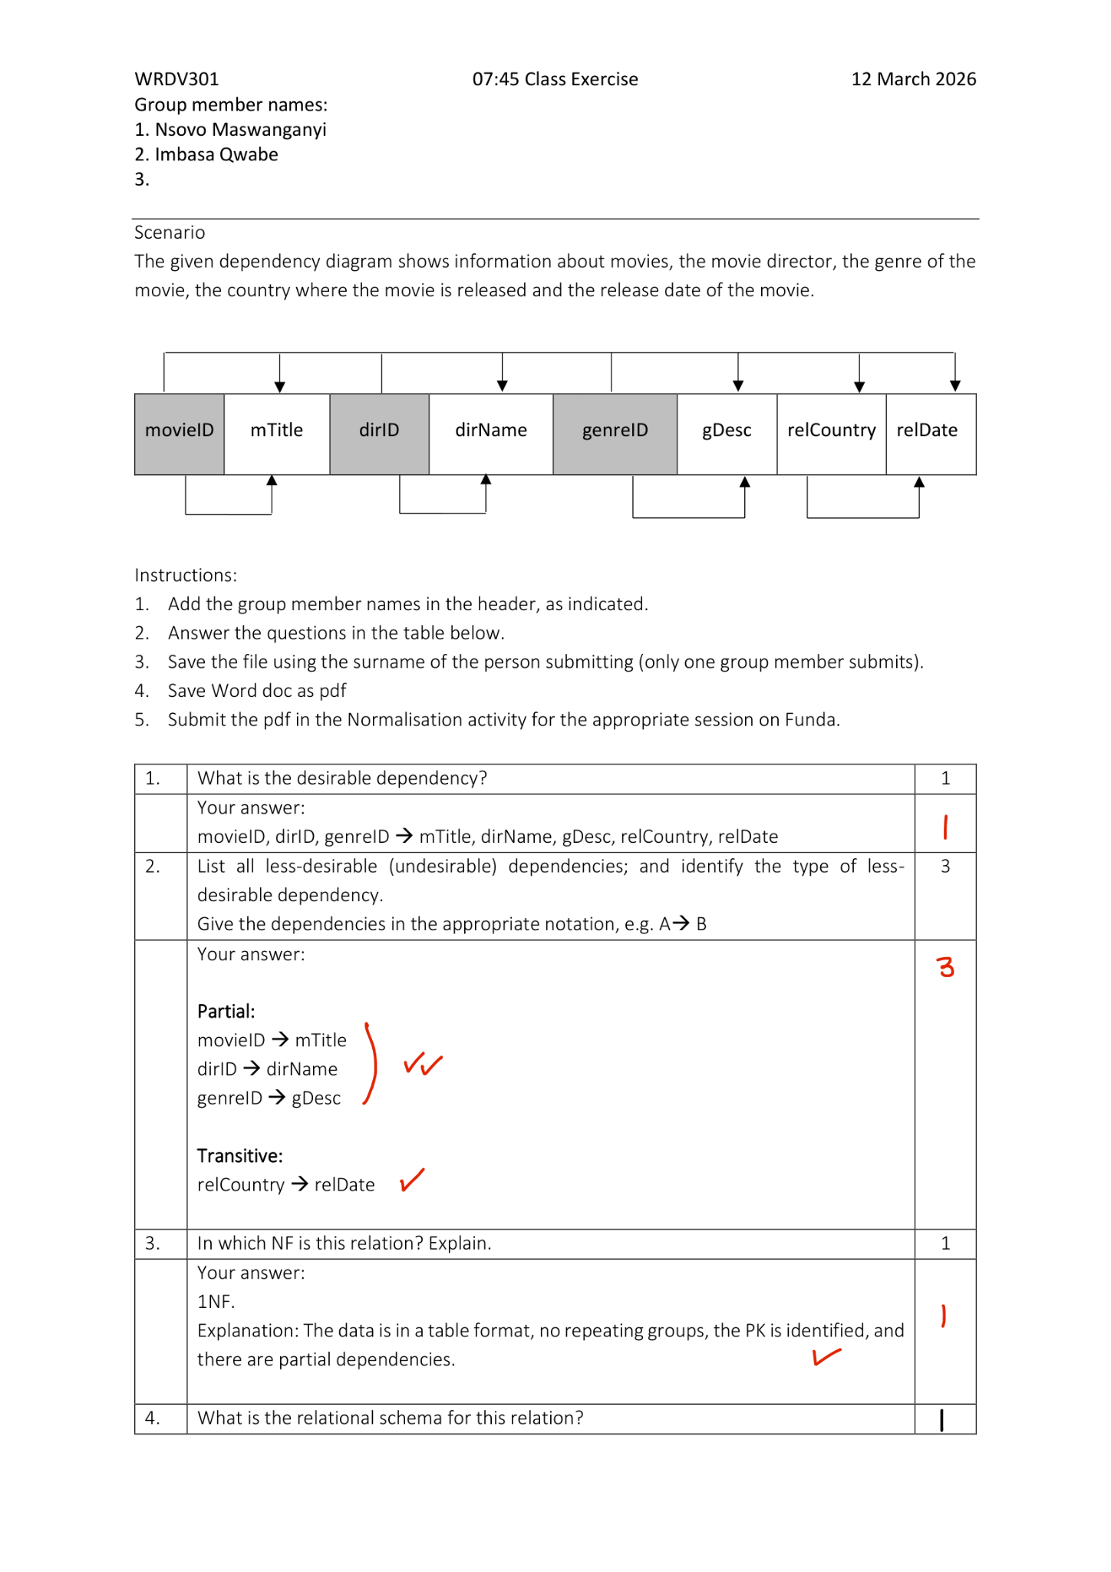
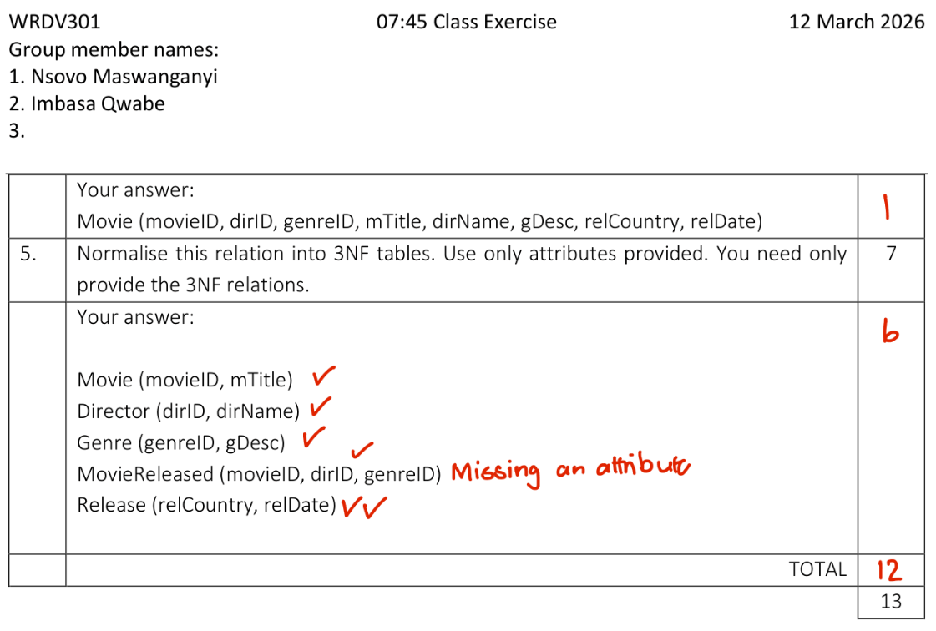

Murder Mystery

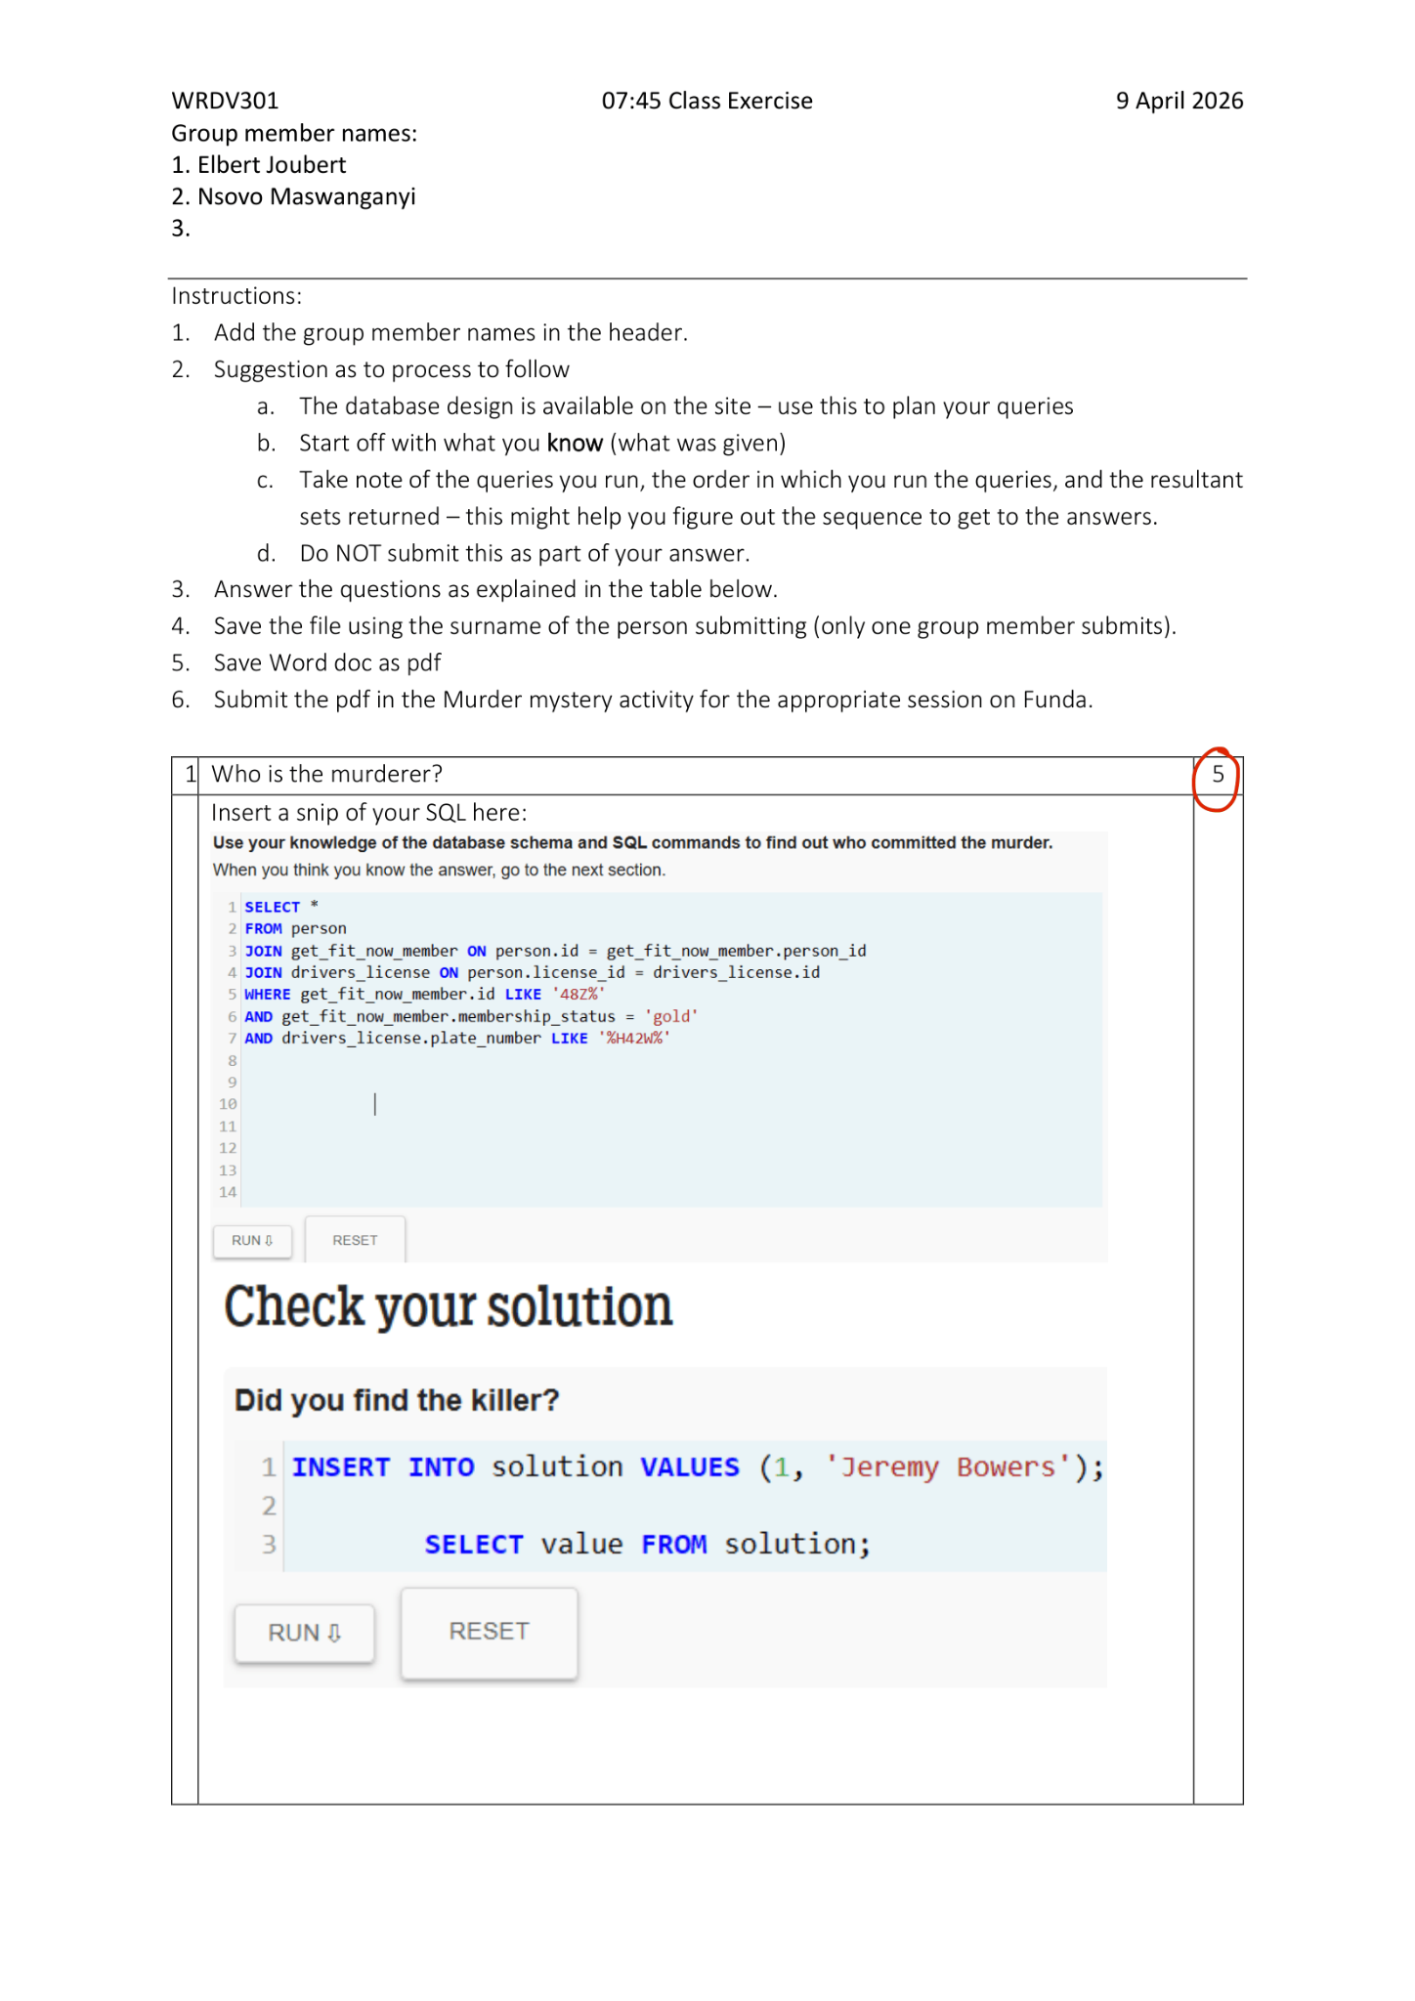
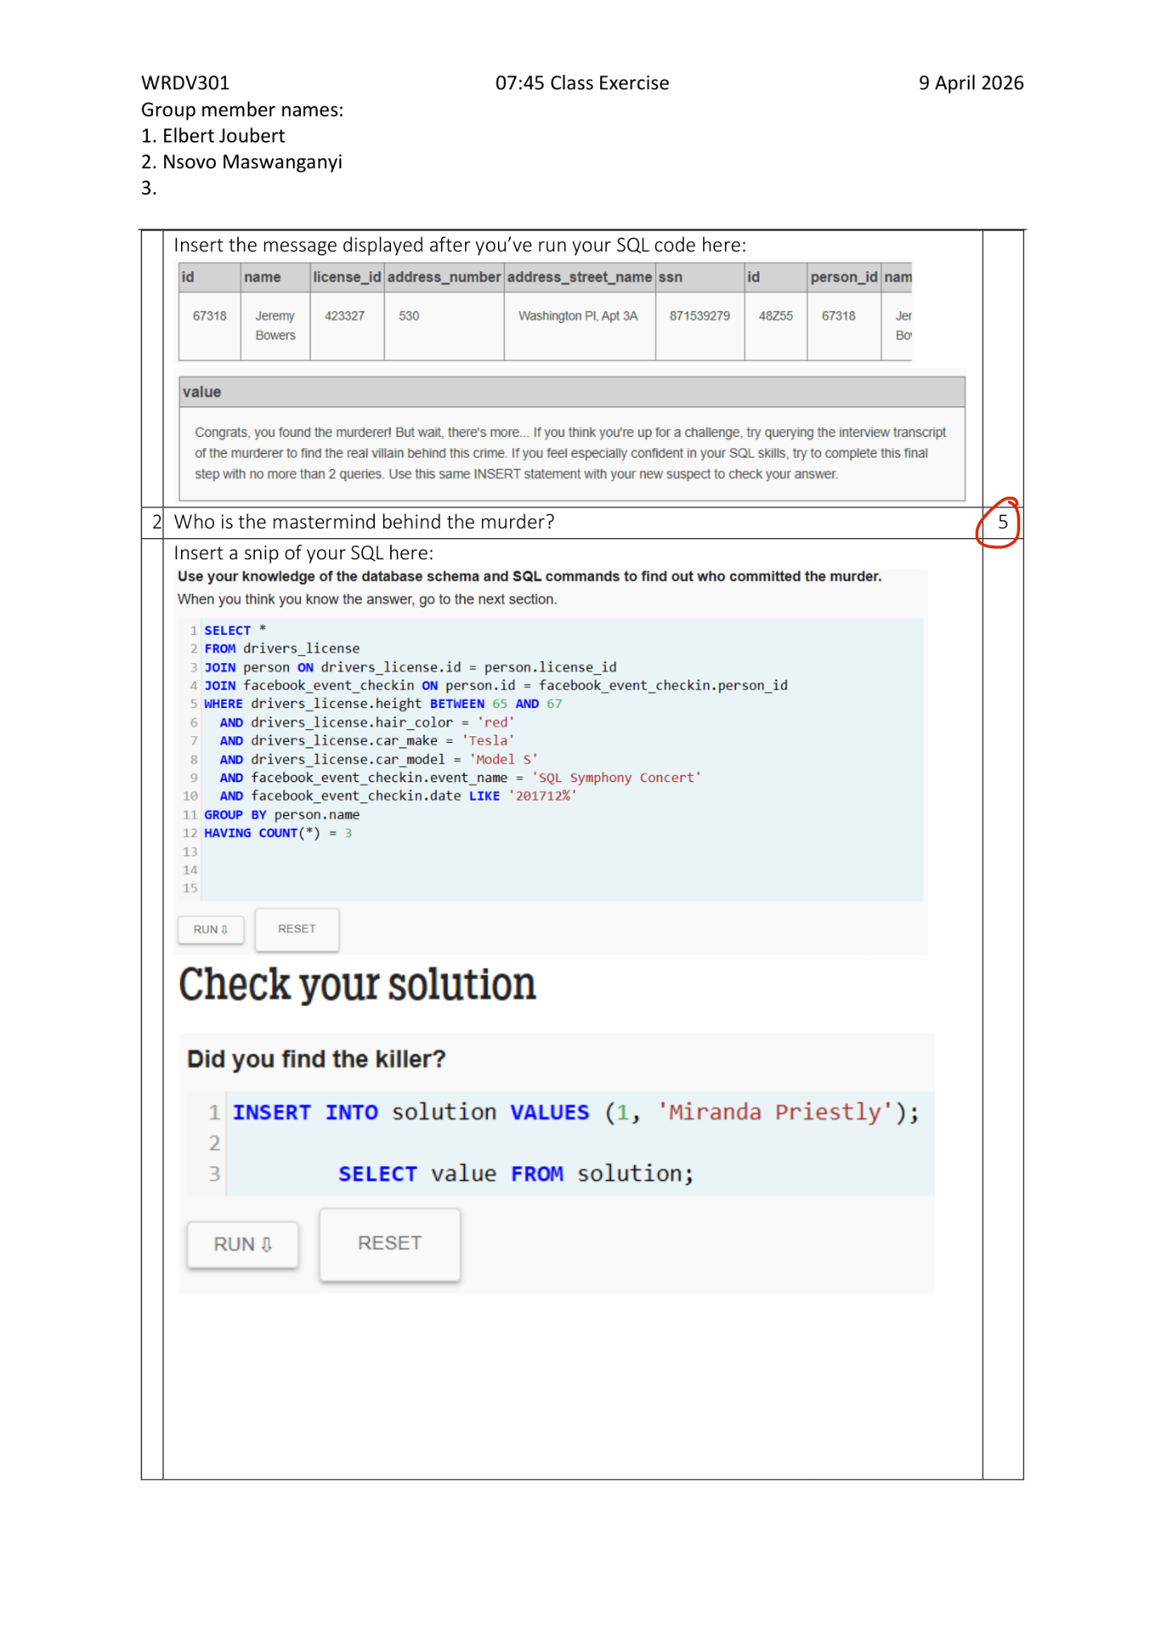


Optimization

No Submission

3. Assignments

Assignment 1 Draft
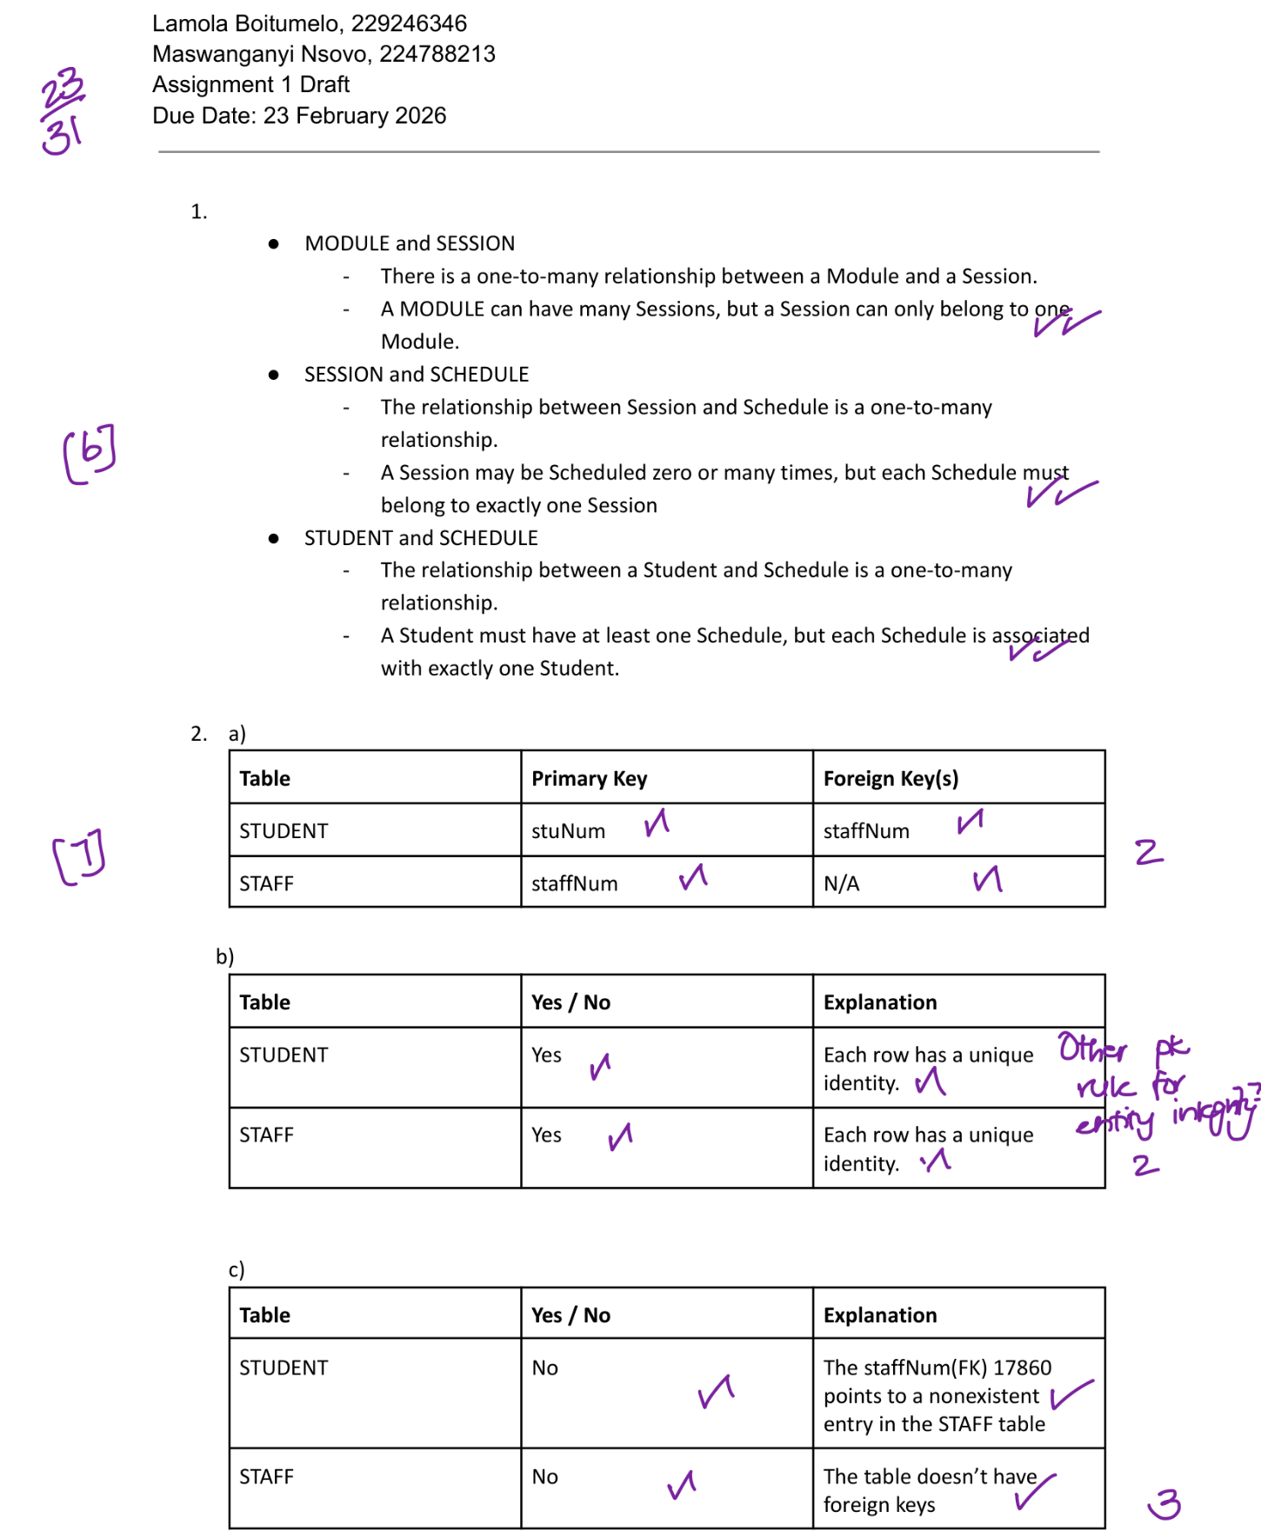
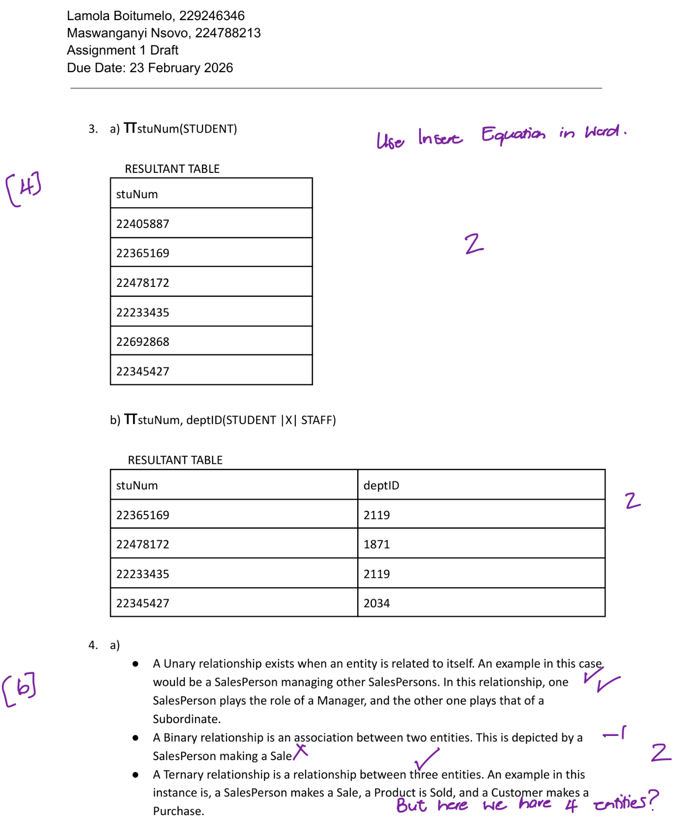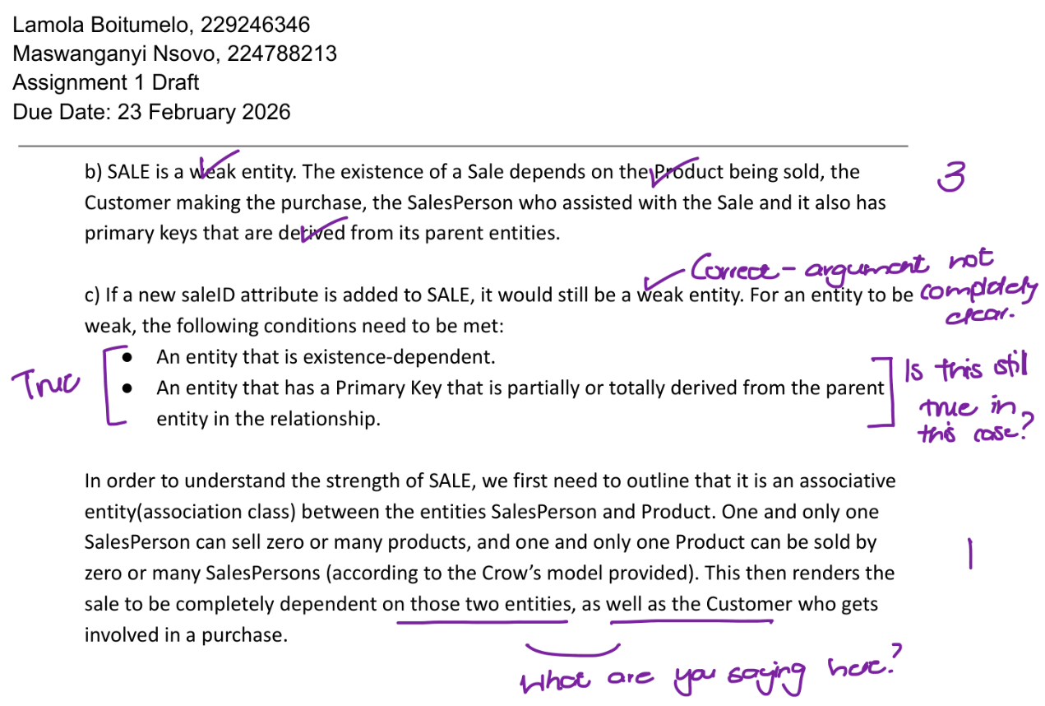

Assignment 1 Final

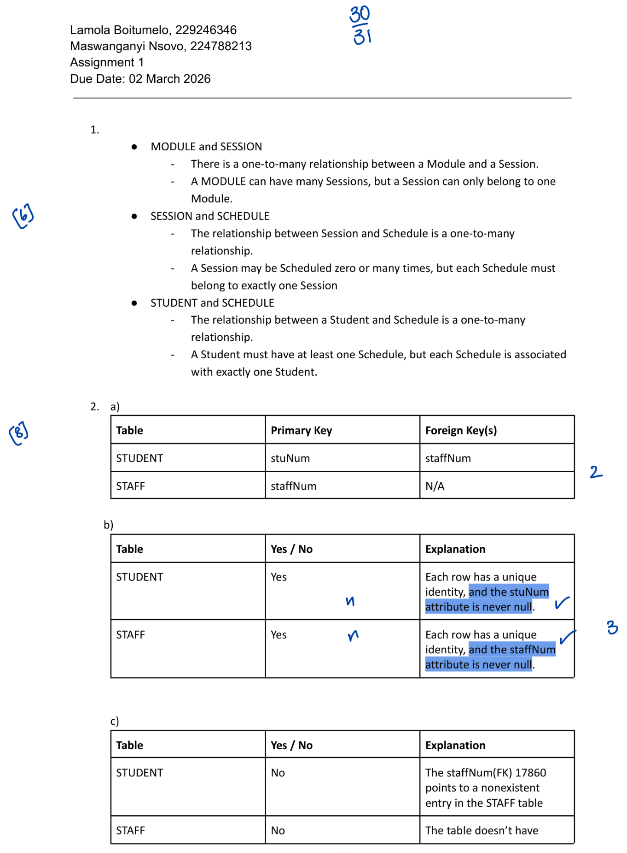
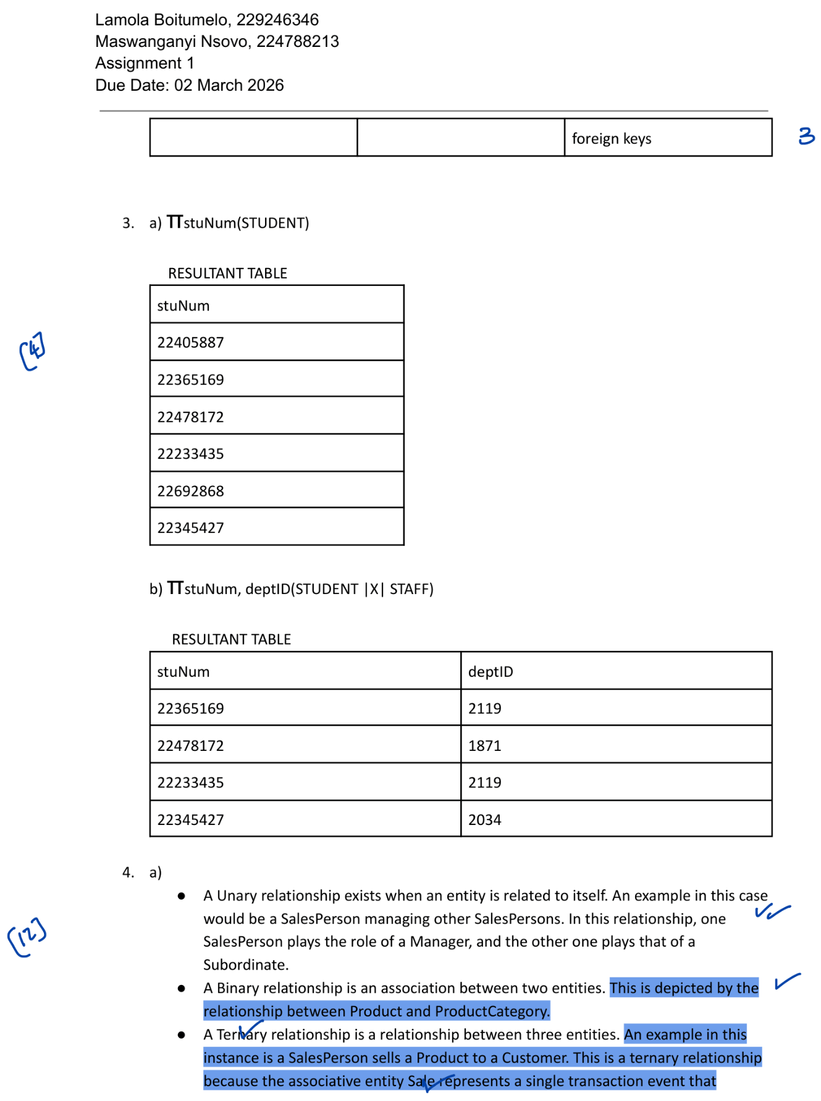
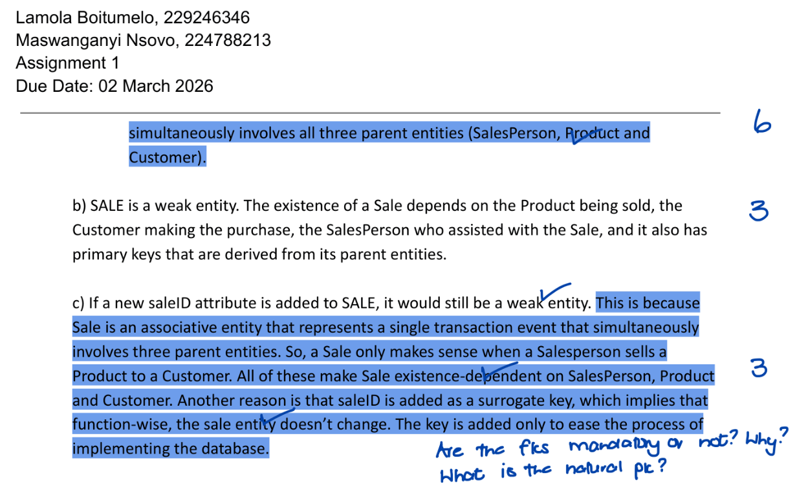

Assignment 2 Draft

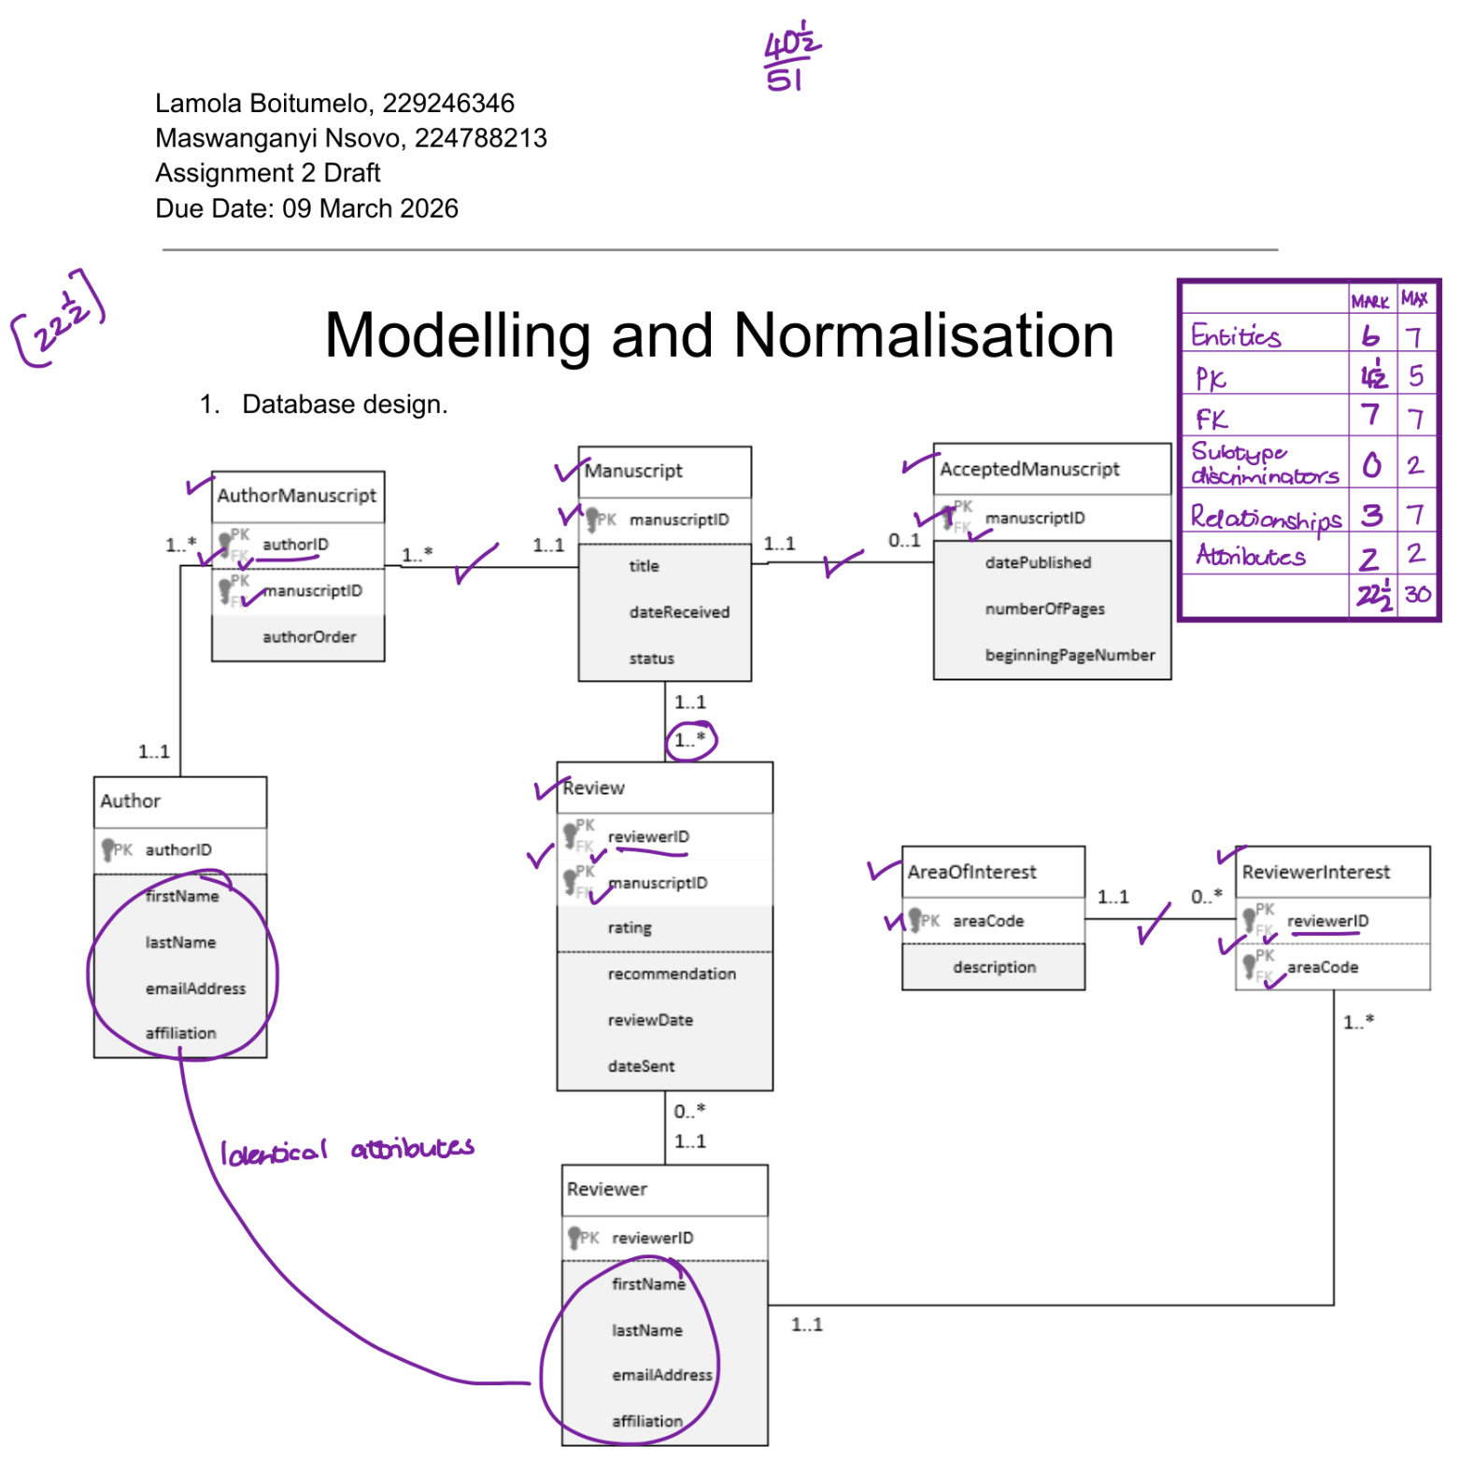
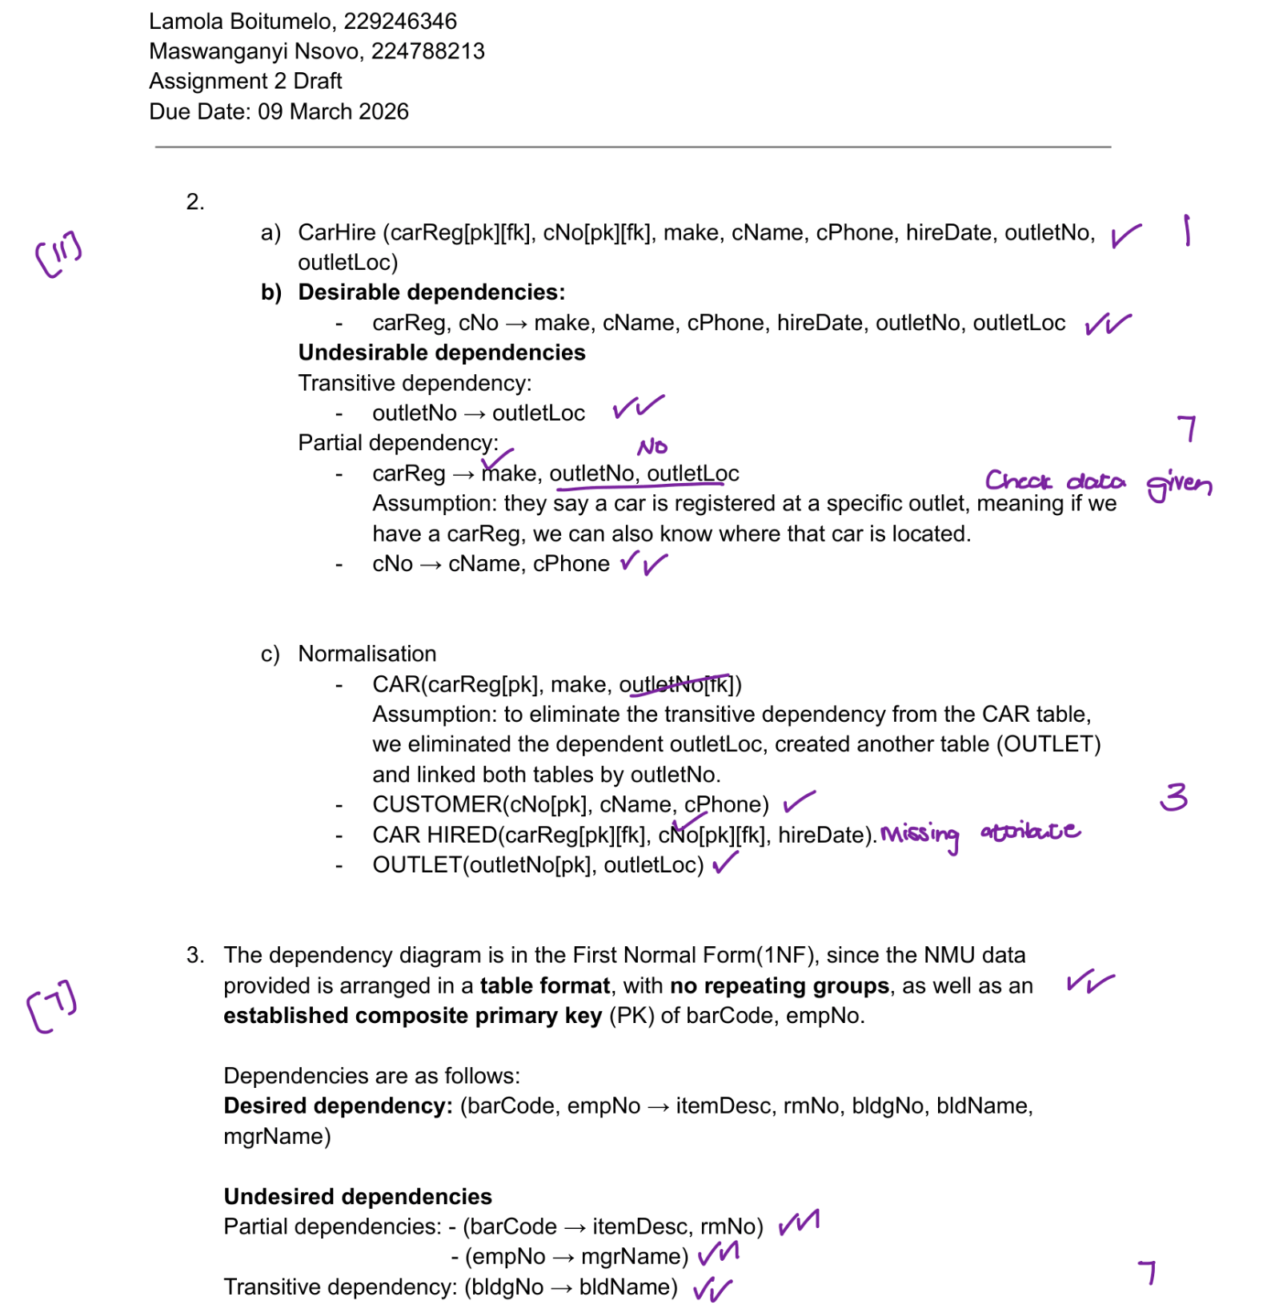

Assignment 2 Final

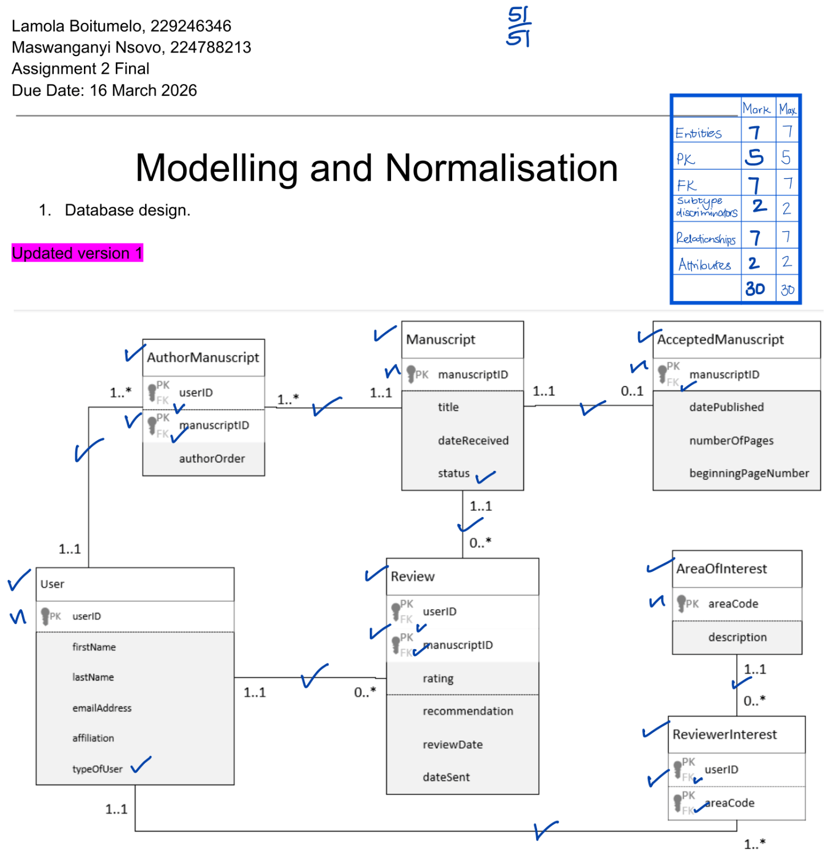
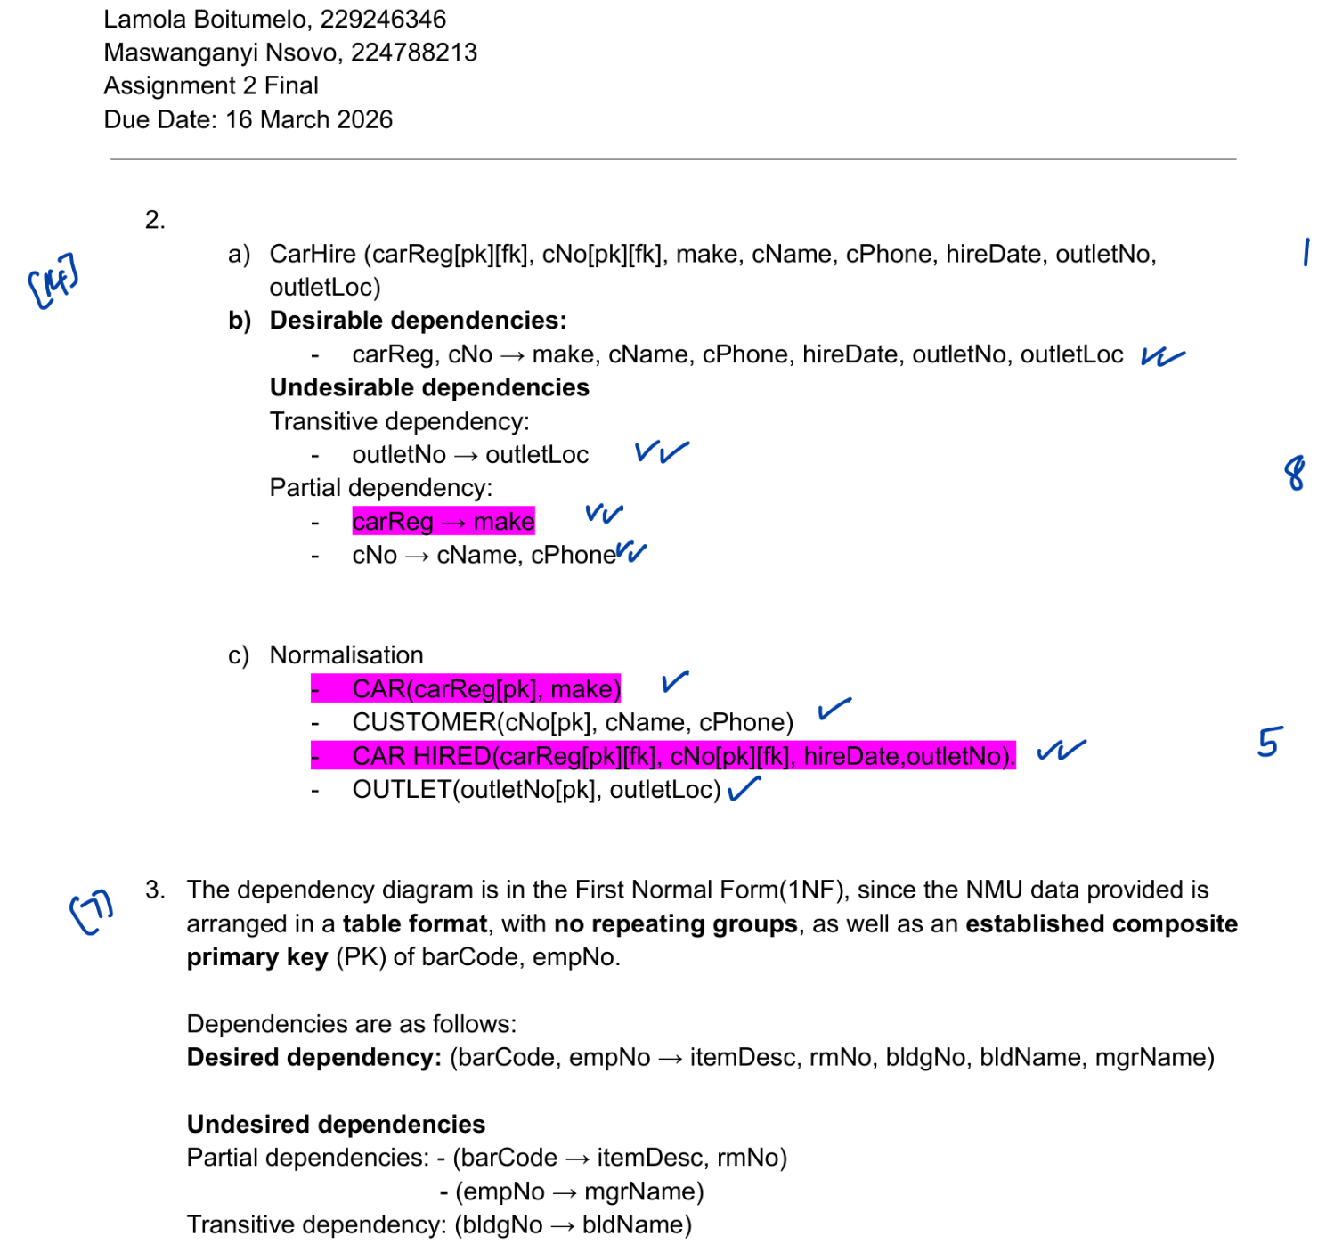

Assignment 3 Draft

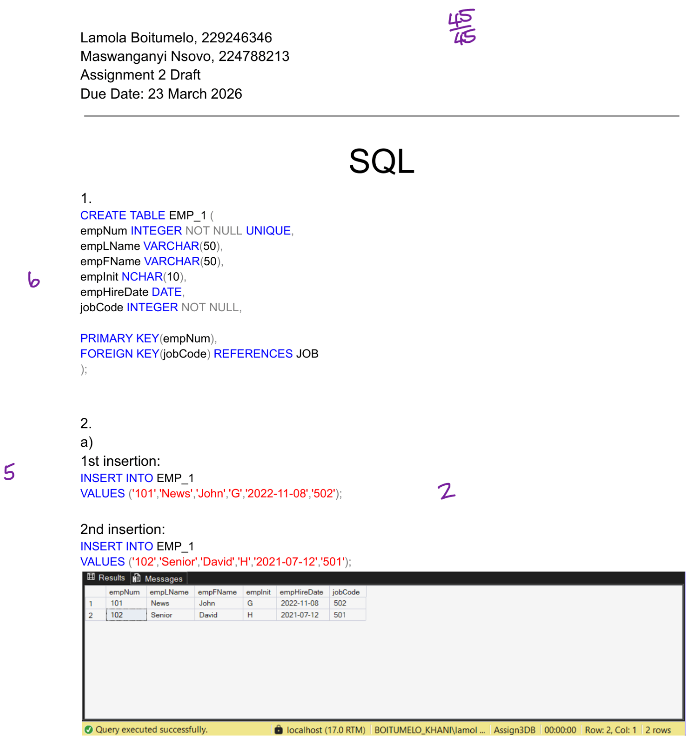
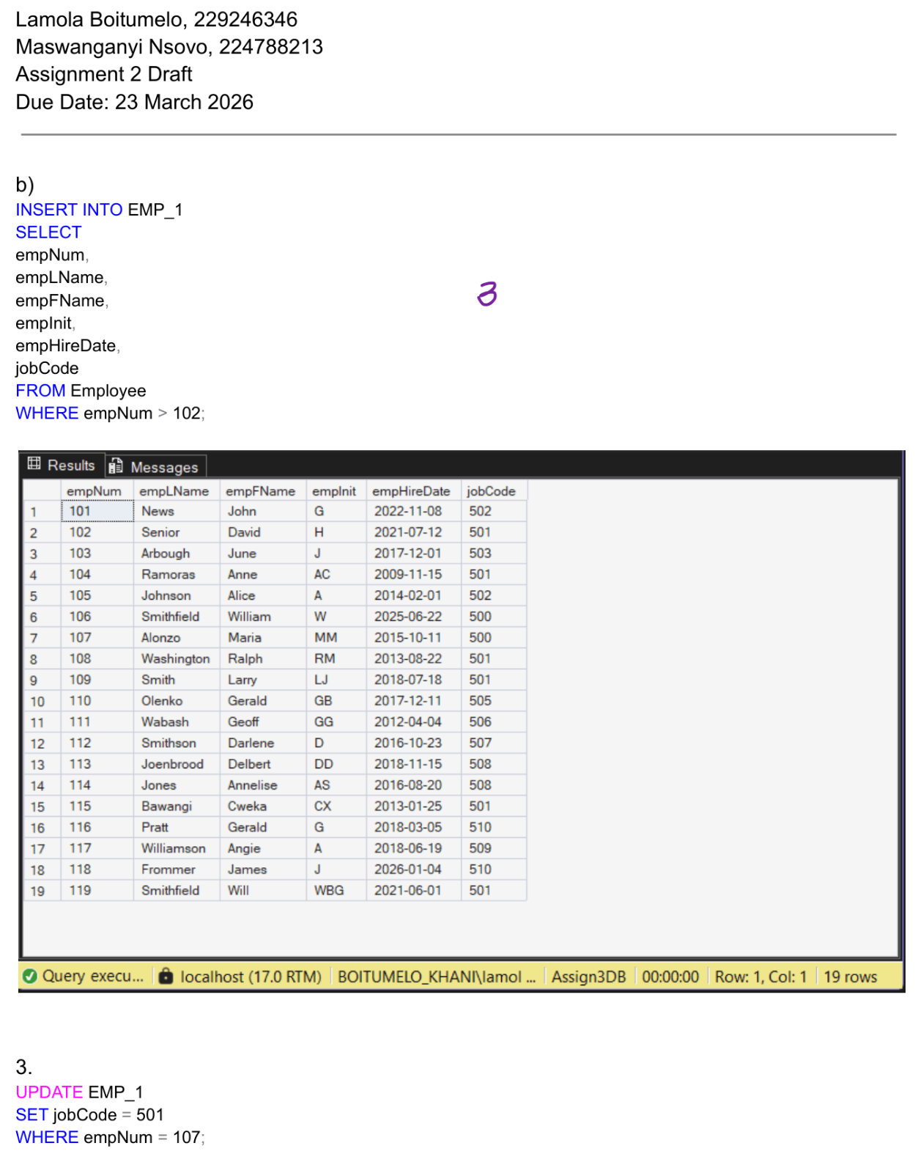
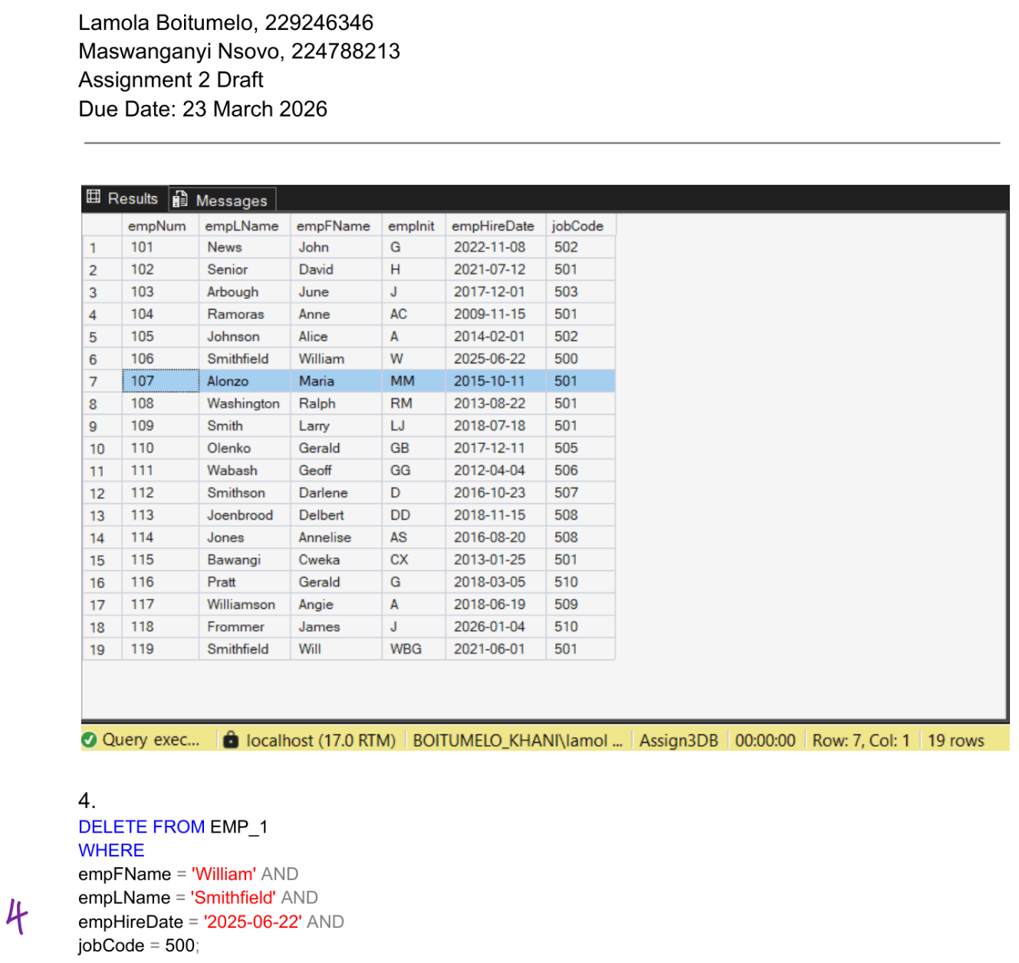
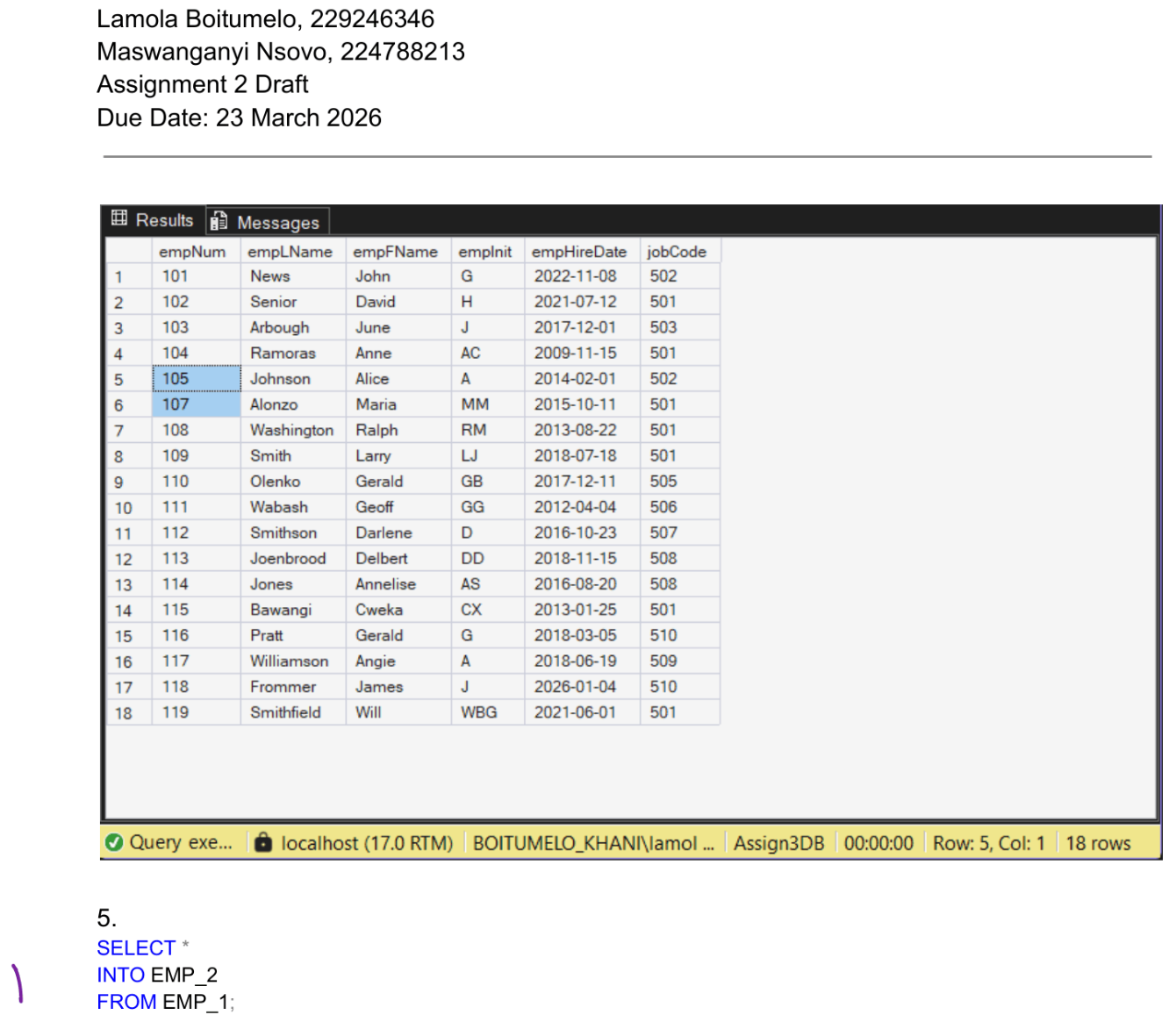
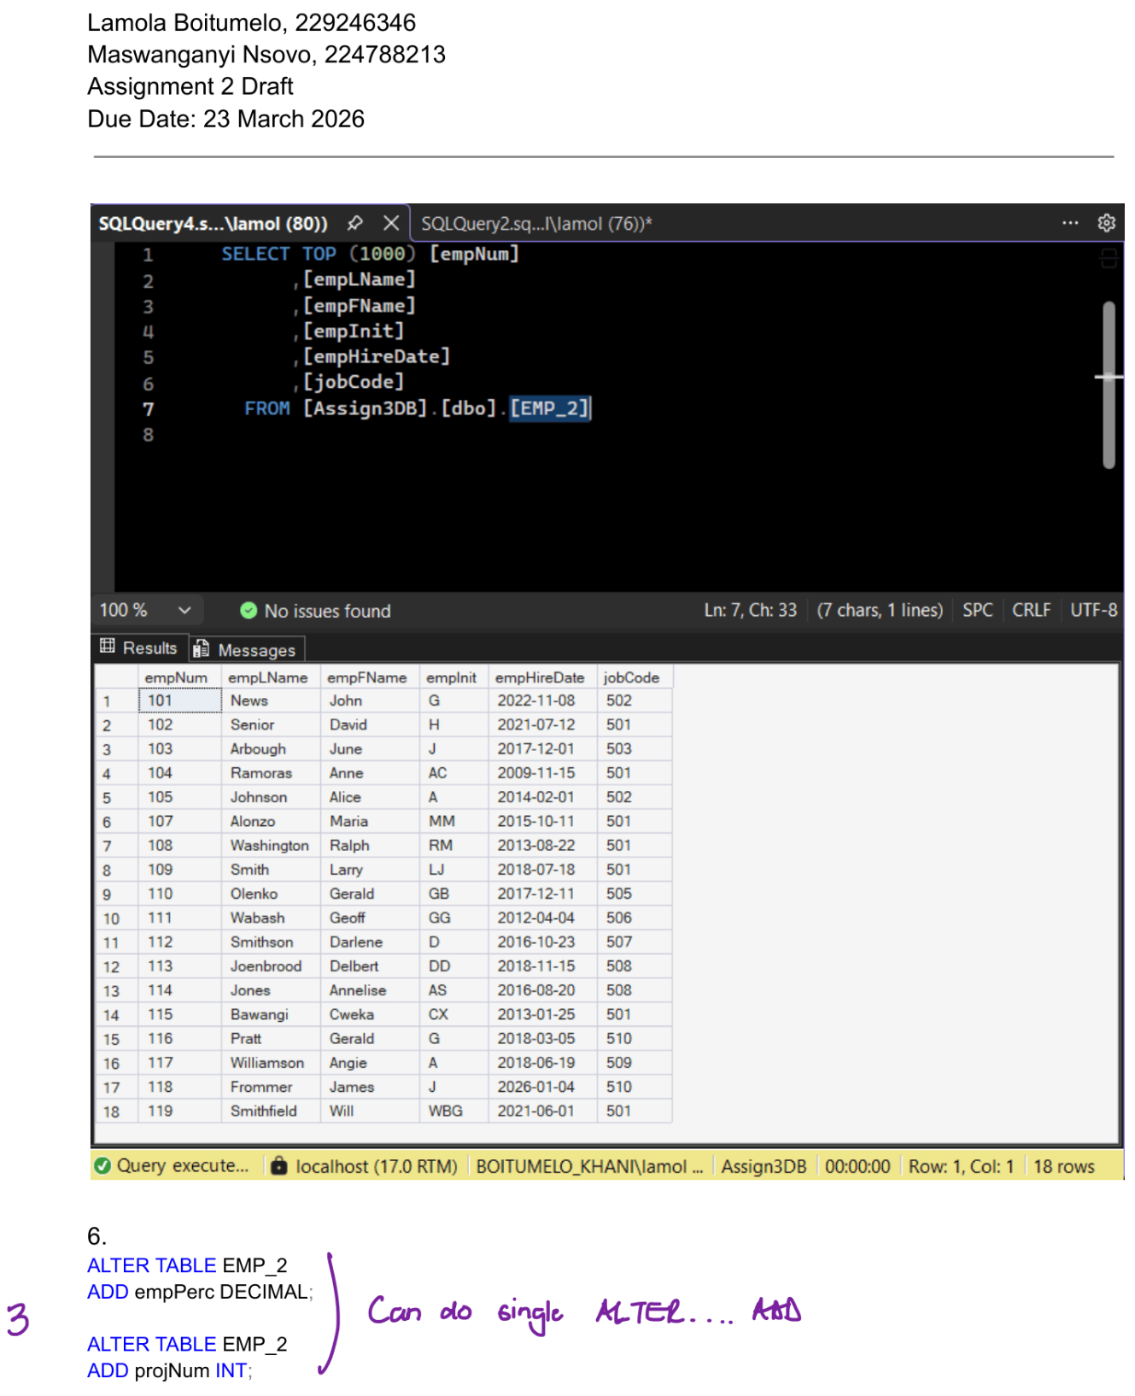
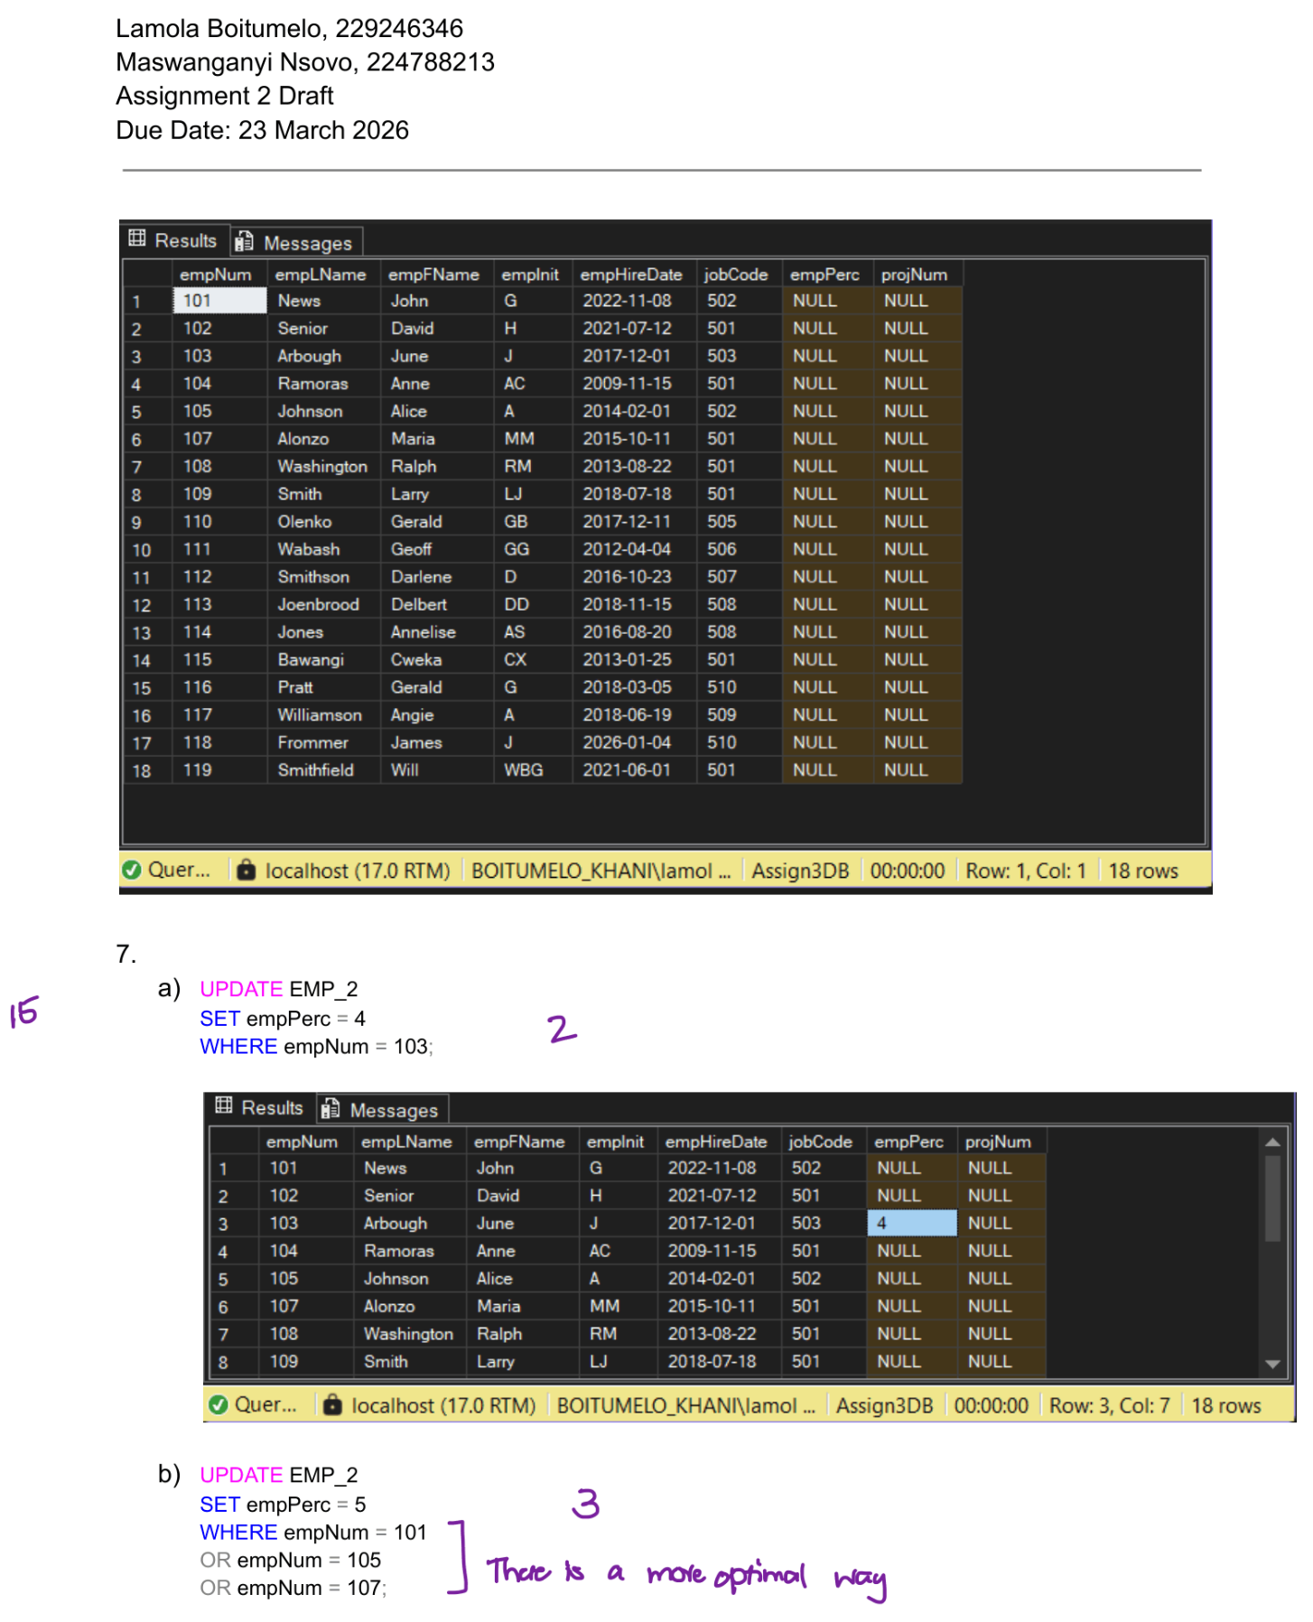
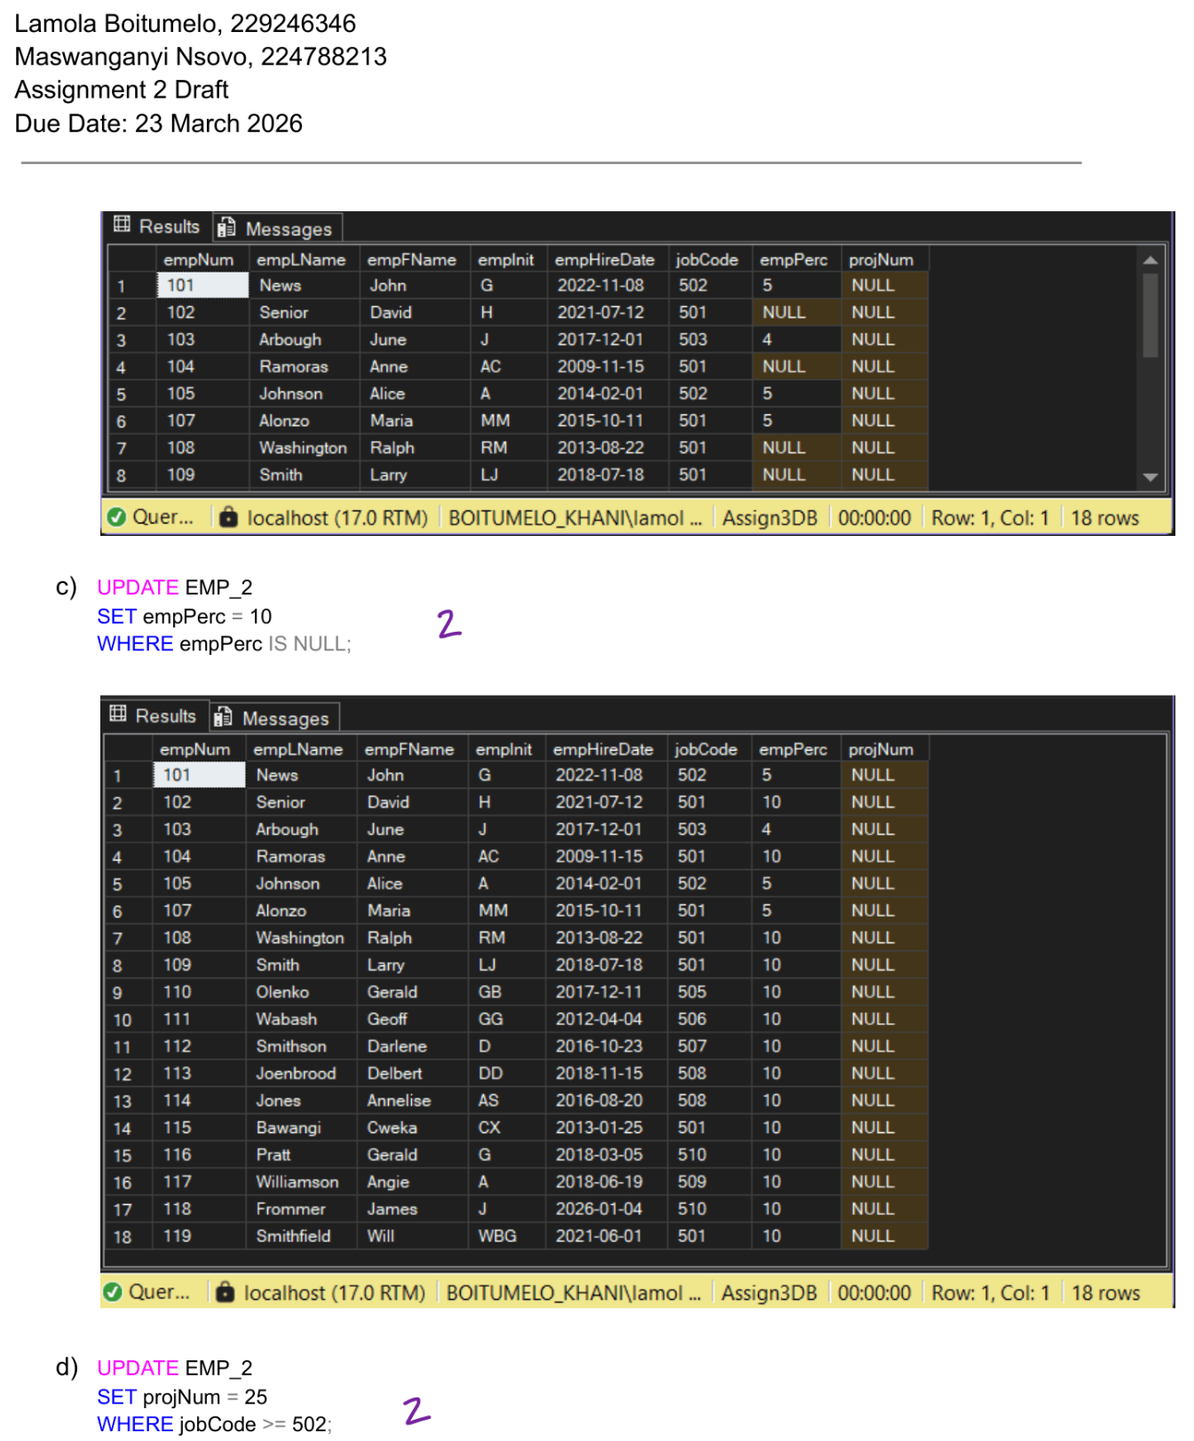
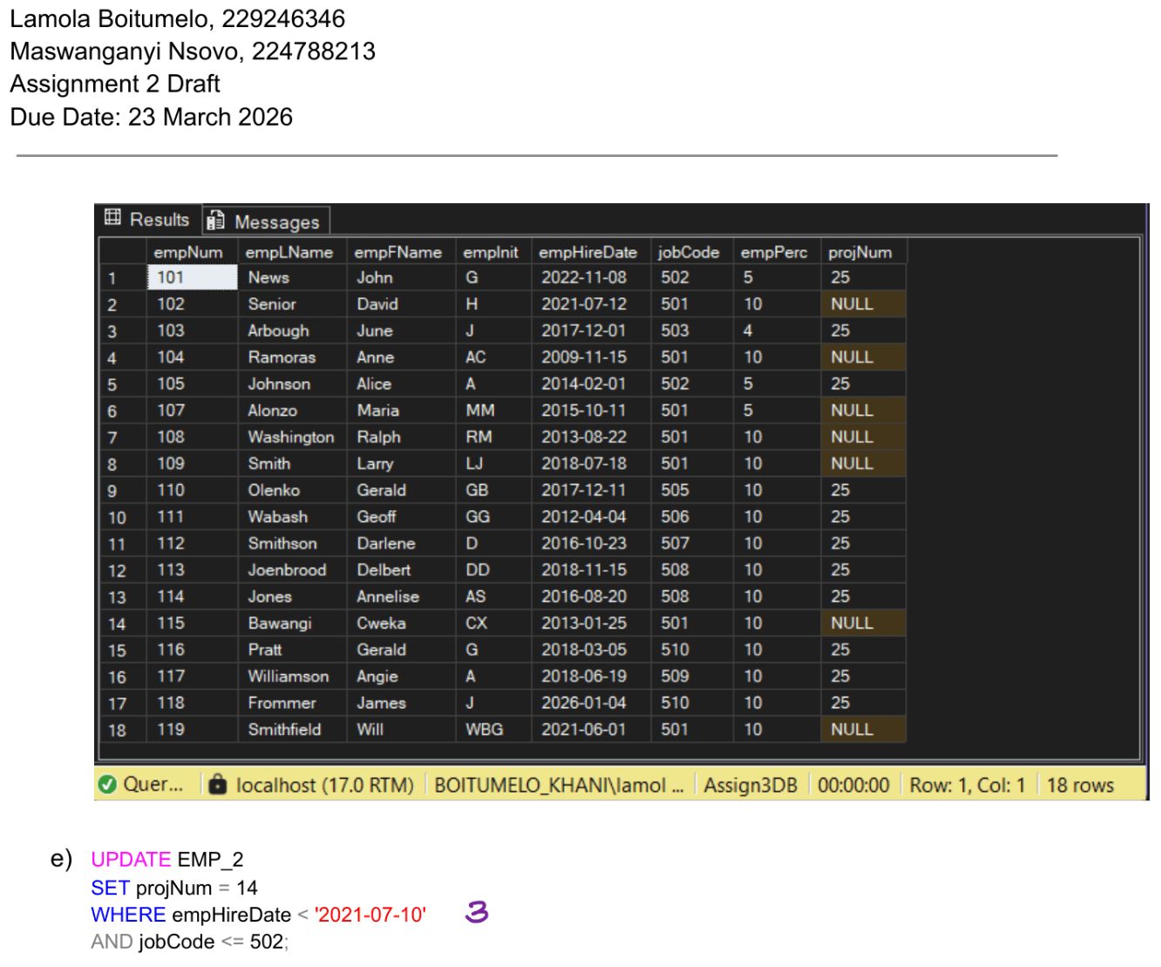
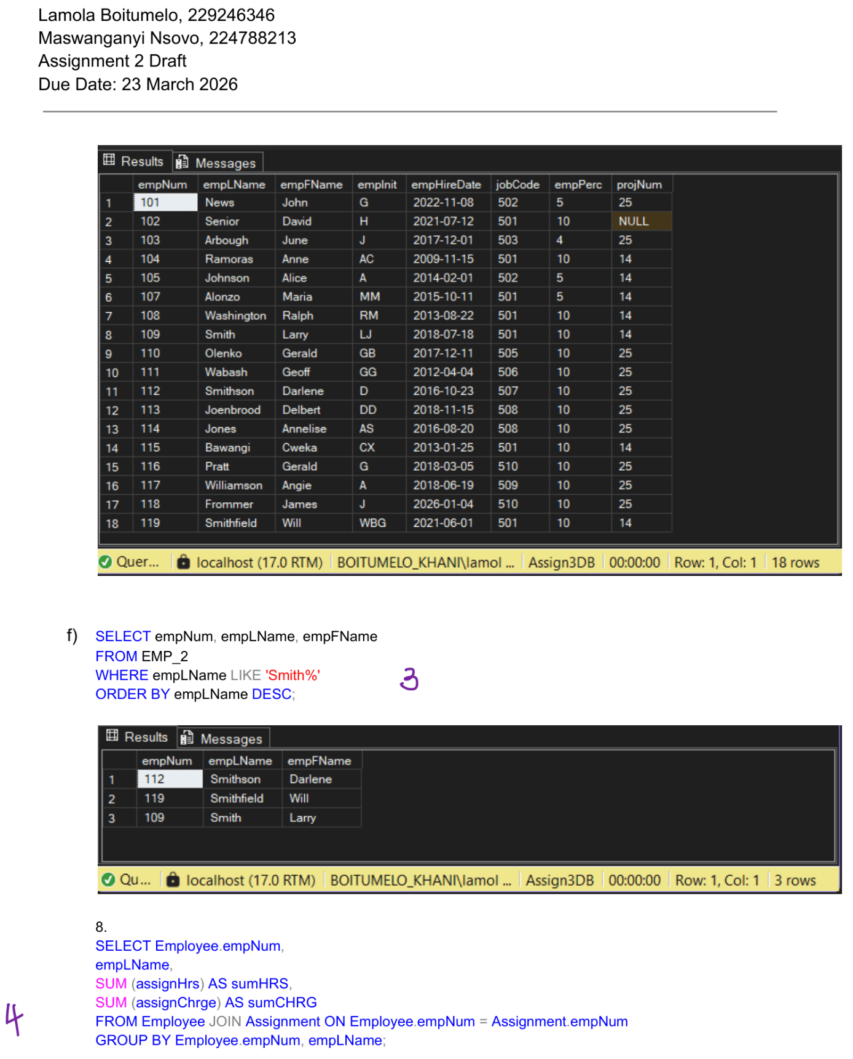
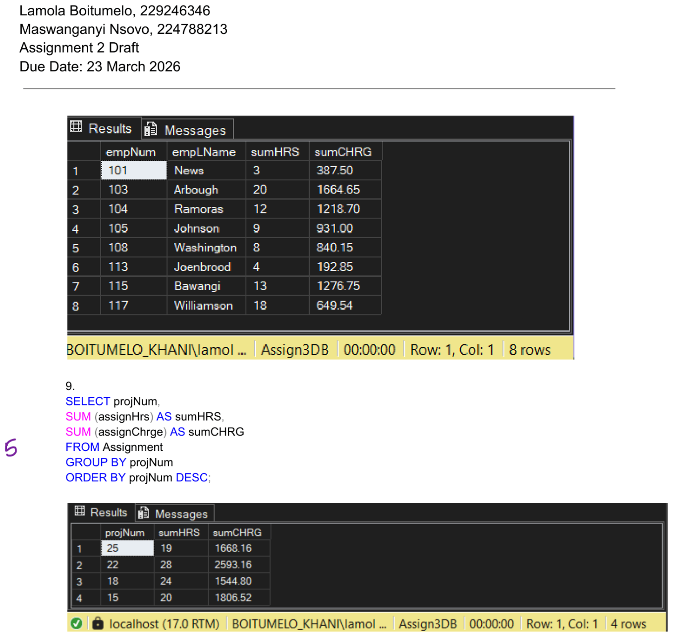

Assignment 3 Final

Same as draft

Assignment 4 Draft

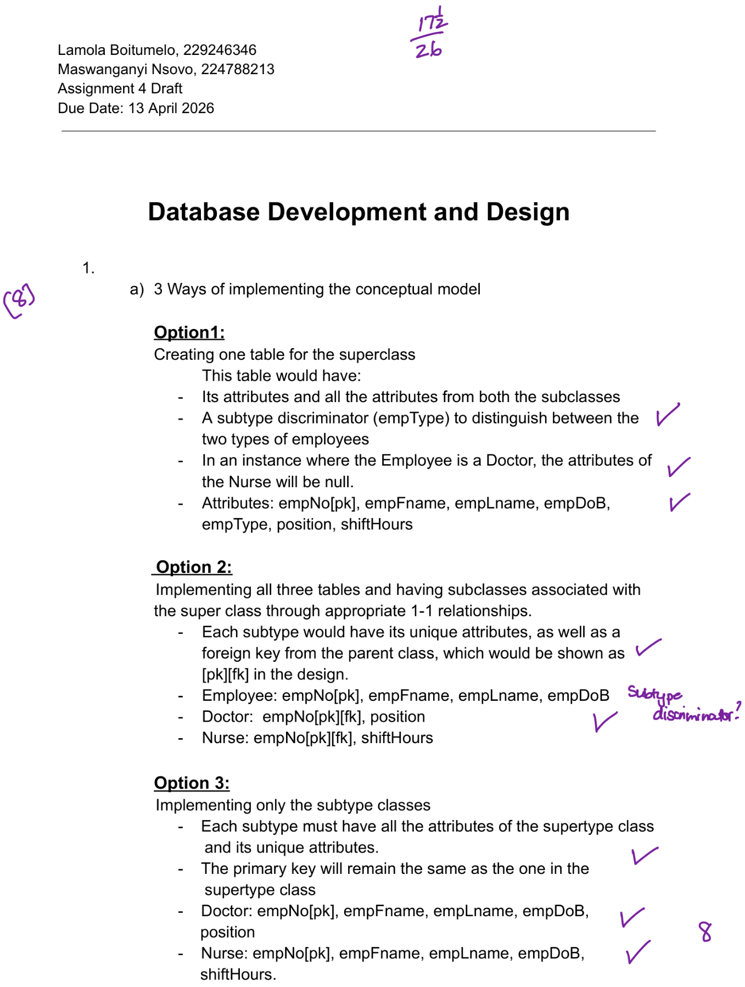
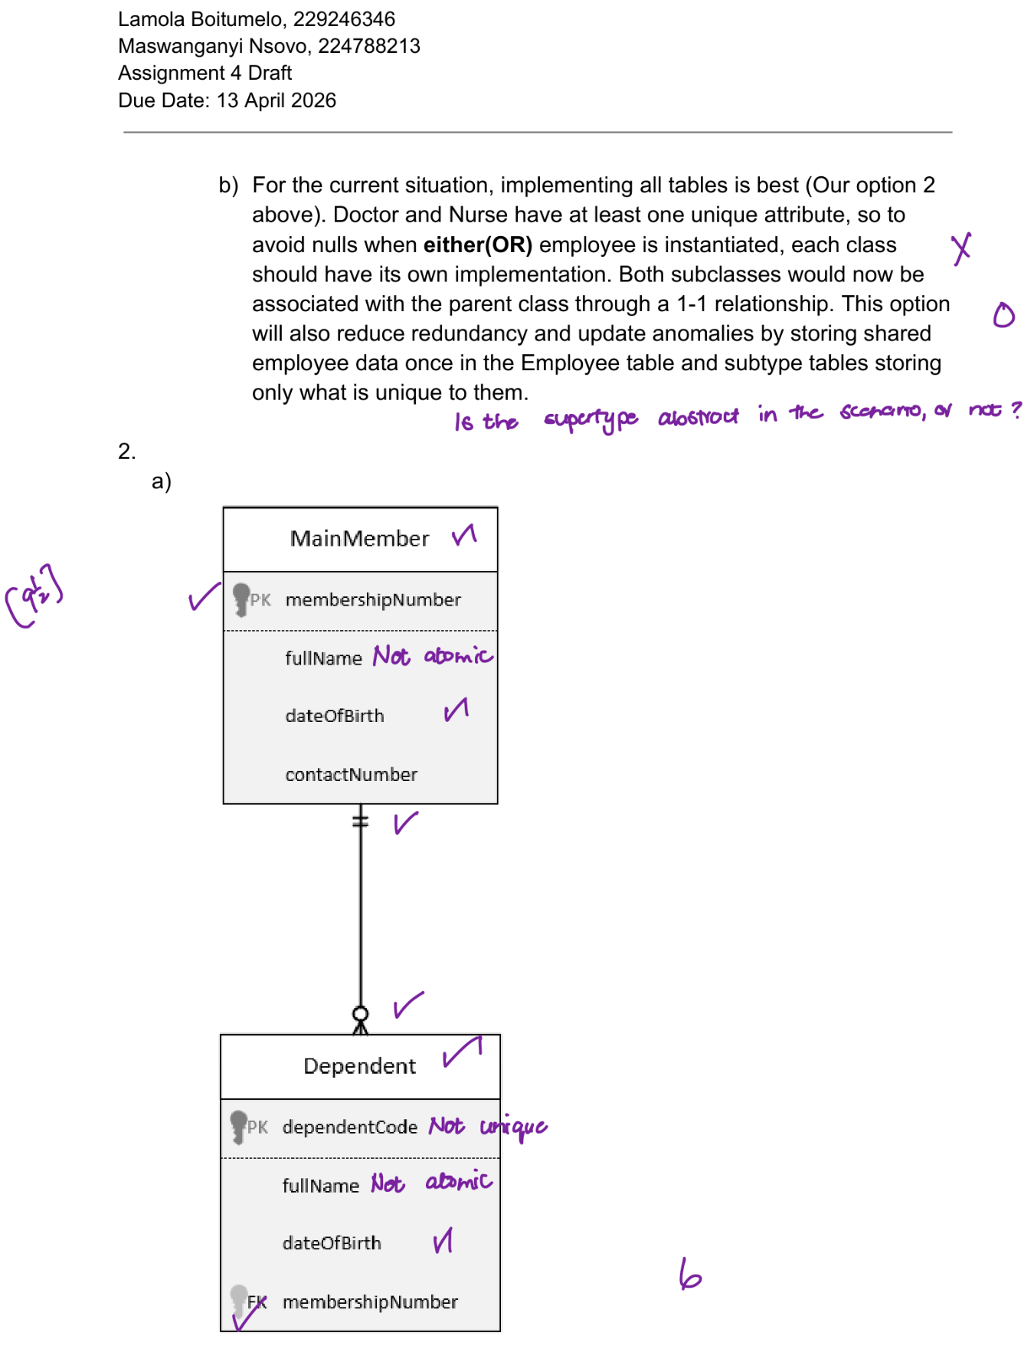


Assignment 4 Final

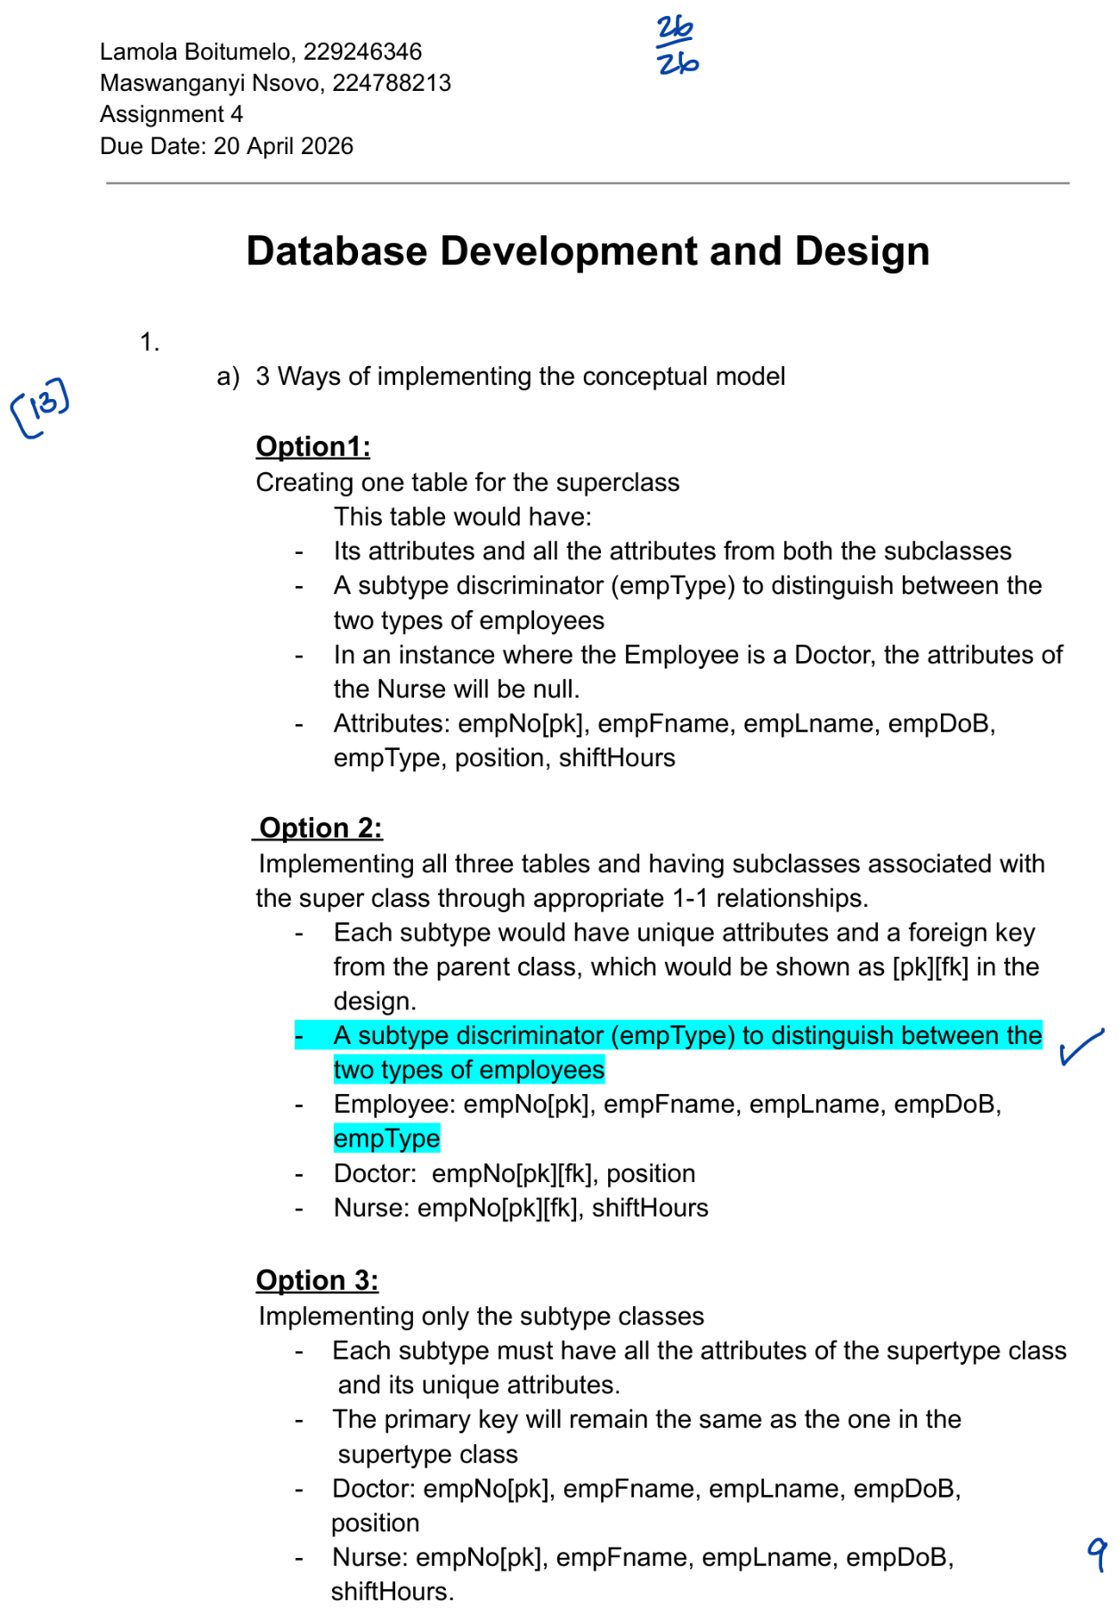
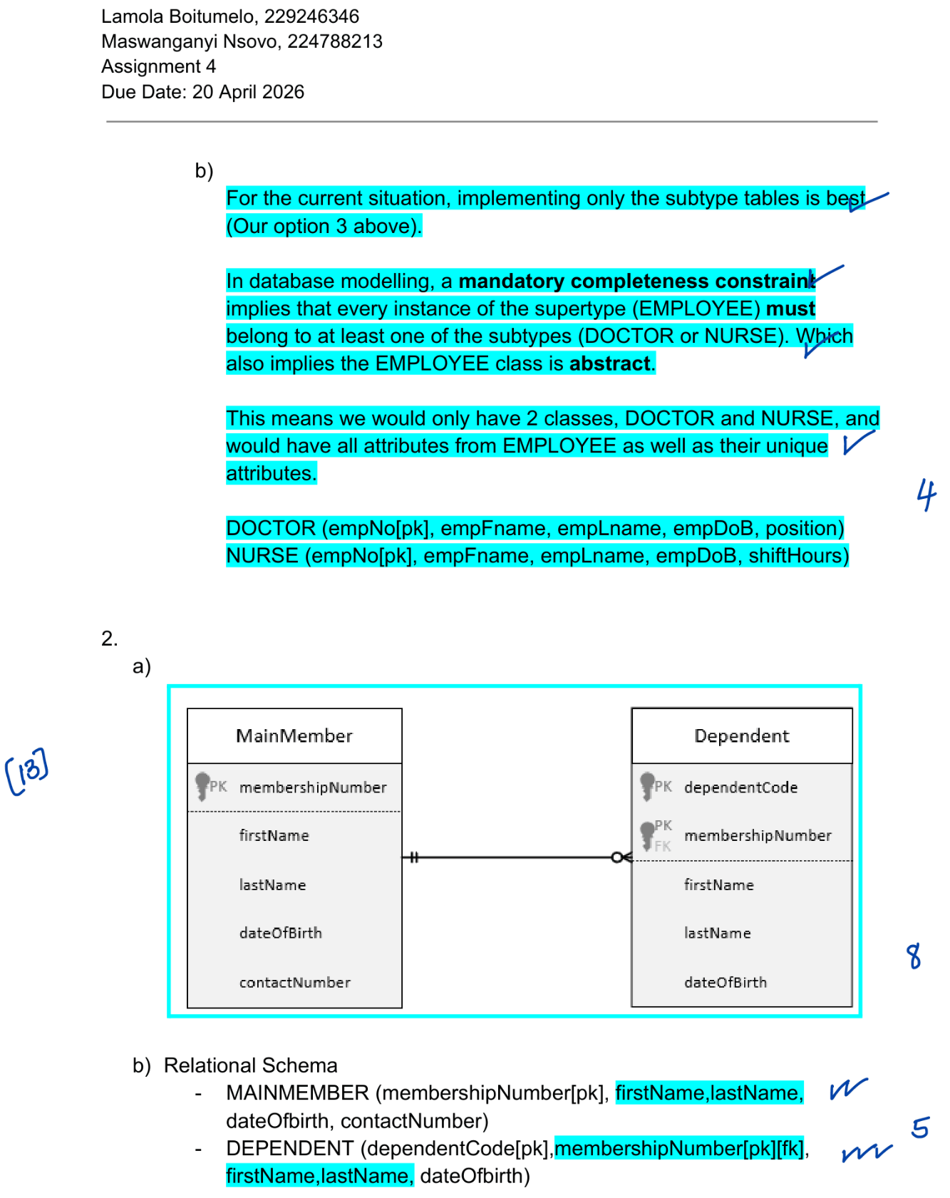

Assignment 5 Draft

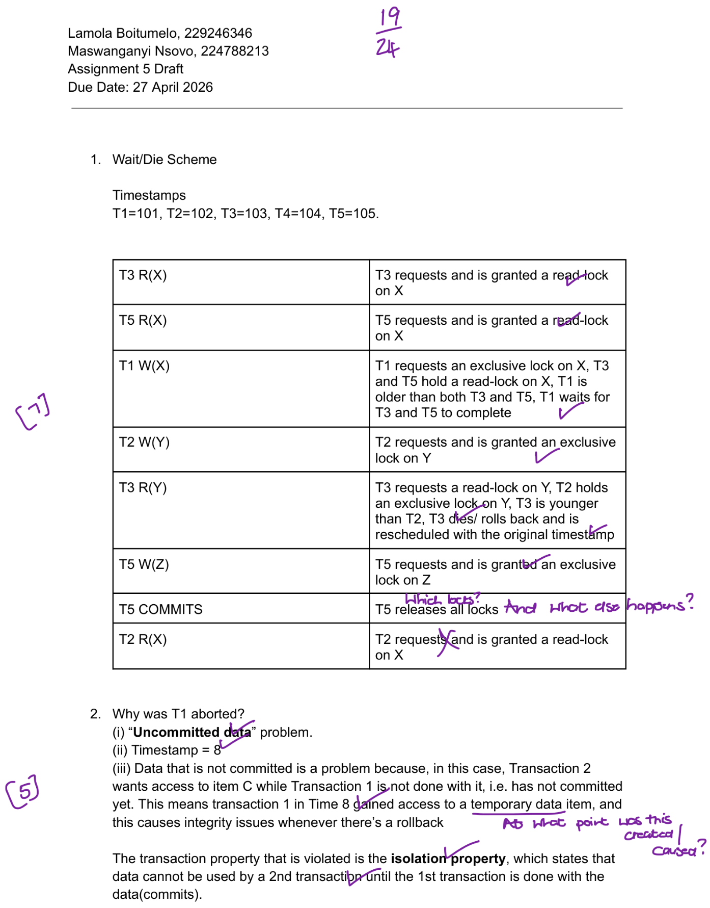
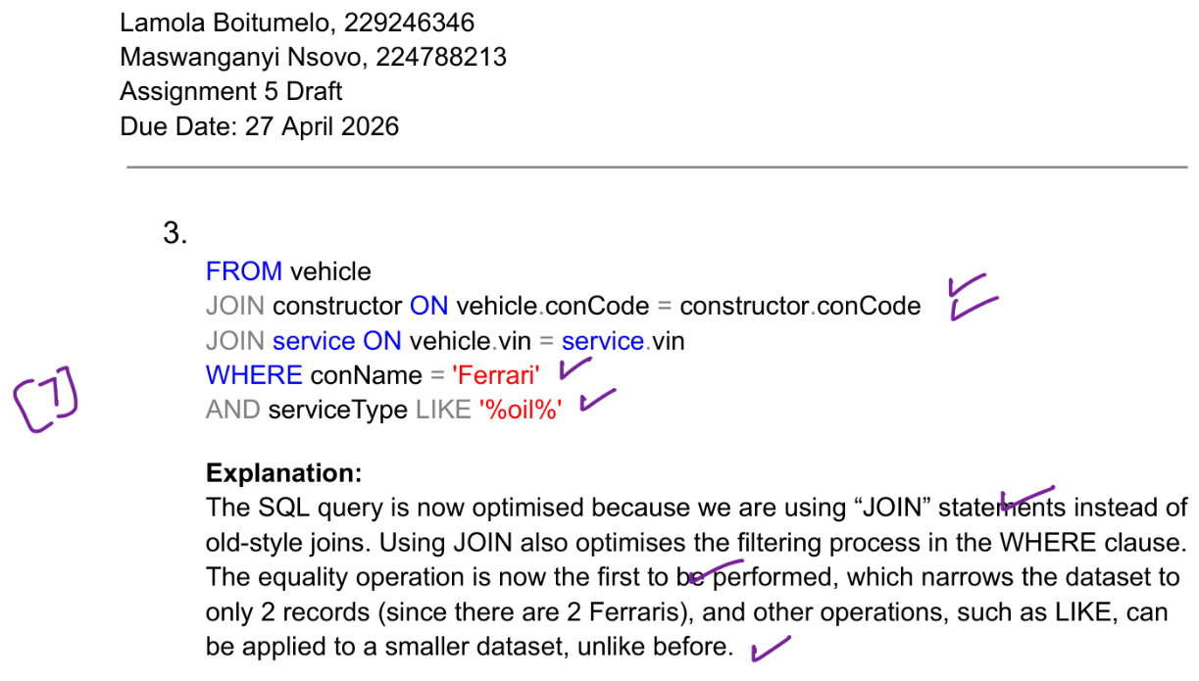

Assignment 5 Final

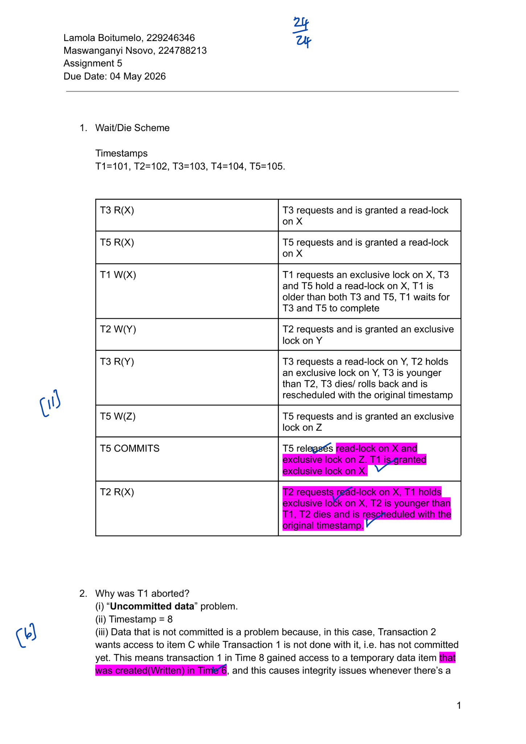
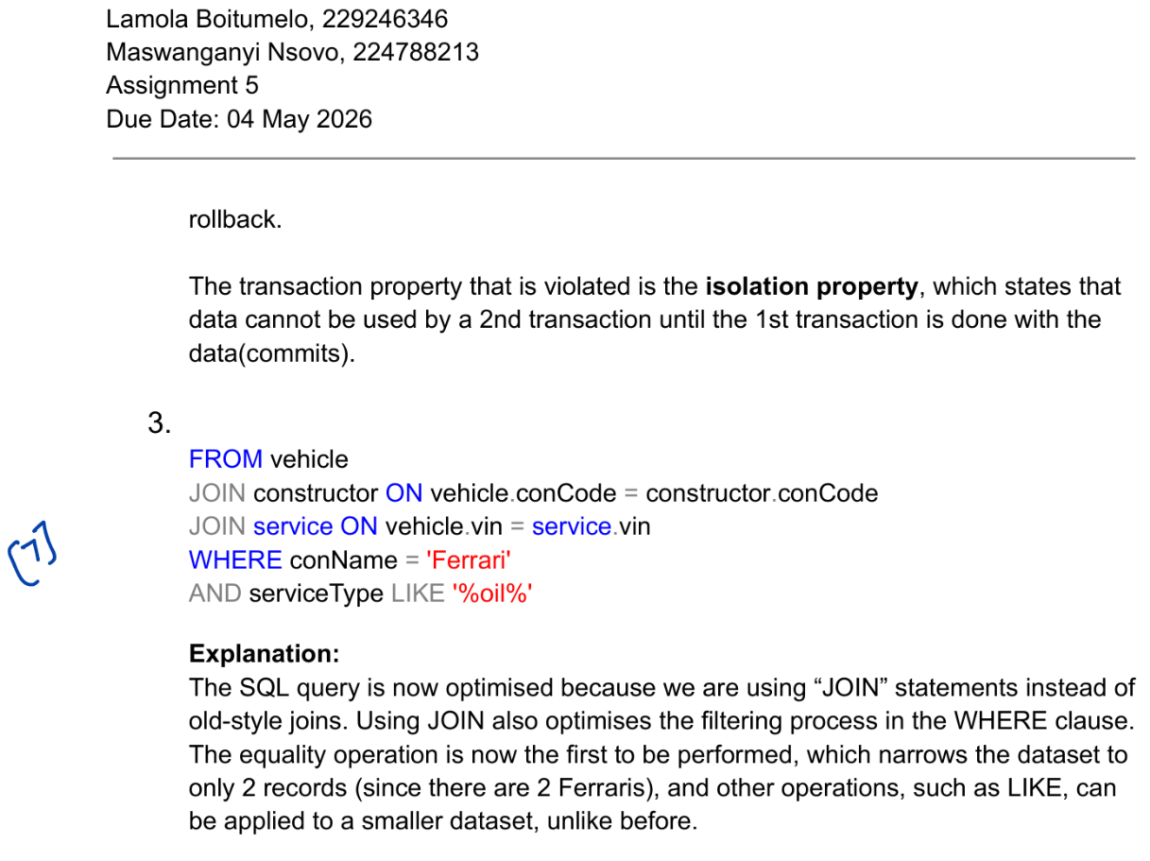

4. Reflection
Databases are a critical concept in our daily lives. To think that everything we interact with on the internet is stored on some database is something that truly blew my mind. It made me realize. It made me realize that behind every simple search, every online purchase, and every social media post, there is a carefully designed system behind the scenes.

I have to say that I’ve been very fortunate to enroll in this module, and being able to draw insights from Dr Barnard on how databases work will be one of the highlights that will stay with me for the rest of my life. Her explanations often went beyond the textbook, showing us how these concepts apply in real-world systems, and that perspective will remain valuable to me.

Below I will go over some aspects that will serve as proof that I have fully participated in this module.

The most valuable concept
Although there are two concepts that stand out for me (Database Design and Distributed Database Management), in this reflection, I will be focusing on Database Design.

Database design act as a foundation of all the databases in the world, and without that foundation, data interaction would most likely be inefficient and unreliable. It is almost like a blueprint of a building; without a solid plan, the structure may not stand firmly, and everything built on top may eventually collapse.

Put simply, database design is the process of planning, structuring, and organizing data according to a specific database model to ensure efficient storage, quick retrieval, and long-term data integrity. What struck me most was how much thought goes into this stage before any queries are written. Sub concepts such as normalization, indexing, tuning, and defining relationships between tables helped me realize that database design is much more than just storing data, but also about anticipating future needs and making sure that the system can scale without crumbling.

Understanding Database design helped me realize that performance is not solely dependent on algorithms alone, but that a well-designed database enables and supports those algorithms, allowing them to work at their best. A poorly structured database can make even the most advanced algorithms struggle, while a well-structured one can make ordinary queries run with remarkable efficiency.

Module aspects done well
One thing that I must give Dr Barnard praise on, is how well structured her lecture slides are. The slides provided me with everything I needed in terms of understanding the concepts. And if you thought that was all, there were videos that were way better than YouTube videos, in quality and the content presented. If I didn’t understand something in class, I knew that watching her videos many times would give me my light bulb moment.

Another thing that I liked about this module were the group class activities. Those class activities may have been the only reason I was able to wake up for my 7h45 class. While doing these activities, I was able to make a couple of friends, since it was my mission to sit next to different people every week so I can meet more people. This helped grow my network of like-minded people, and not to mention how fun these activities were.

Finally, another thing that made a difference in my learning this semester was the idea of draft assignments. My partner and I were able to nearly ace all assignments because of the valuable feedback that was given in the draft assignments. The draft feedback gave us a platform to rethink our ideas and how we approached questions which made us perform well in our final assignments.

Module aspects that need improvement
One thing that I found lacking in this module was the absence of student assistants. According to me, student assistants do more than just assist students with course work, but they also share experience as seniors. Getting to know someone who has been on your path is refreshing. It is something that I missed in this module. As amazing as Dr Barnard is, being a lecturer for very long does create some gap between students and lecturers, but someone who did WRDV301 last year may have insights that can help me as a student, such as what to expect in the assessments and so forth.

Life lesson

One lesson I have learned from this module (I guess two in my case), is being detail oriented and always showing up.

In designing a database, a lot of aspects must be taken into consideration. This helped me to sharpen my “attention to detail” skills, which will ultimately help me as I pursue my career in Software Engineering.

In case of showing up, waking up for the 7h45 class taught me resilience which will be useful in the workplace. Due to this, I am now a morning person, implying that everything important should be handled in the morning!



